GUIDEBOOK
for Astana IT University students
2020-2021 academic year

Nur-Sultan
2021

Dear students!
I am sincerely glad to welcome you in Astana IT University.
Our young University was established on the initiative of the First President of the Republic of Kazakhstan Nursultan Abishevich Nazarbayev within the framework of the Government program "Digital Kazakhstan".
Our main task is to train specialists with modern IT-competence in international educational programs with higher and postgraduate education, as well as retraining of personnel for business, public sector, national companies and various industries.
Currently, the University conducts 9 undergraduate educational programs in the context of 4 training areas (6B04101 IT Management, 6B06301 Cyber Security, 6B06201 Telecommunication Systems, 6B06105 Media Technologies, 6B06104 Industrial Automation, 6B06103 Computer Science, 6B06102 Big Data Analysis, 6B06101 Software Engineering, 6B03201Digital Journalism).
In September 2021, admission is planned for 2 new educational programs 6B04102 IT Entrepreneurship, 6B06202 Smart Technologies.
AITU has institutional accreditation from the Independent Accreditation and Rating Agency for 5 years.
All educational programs have successfully passed the procedure of international specialized accreditation.
Our University has developed innovative educational programs, has classrooms equipped with the latest technology, laboratories of global IT-companies, covorking centers, and employs highly qualified teachers - graduates of leading universities in the United Governments, UK and Germany. In short, a comfortable educational environment is created.
We closely cooperate with domestic and international companies in the IT industry, students of Astana IT University undergo practical training on the basis of our partners - Huawei, Microsoft, Kaspersky, CISCO, Lenovo, HP, and others.
We provide the opportunity to study under the mobility program in foreign universities - Green River College, IGlobal University (USA), University of Latvia, Dortmund University of Applied Sciences and Arts (Germany), Weihai Professional College (China), etc.
Our principle: “talented students - talented teachers - successful country!”
Since September 1, 2021, the university gives opportunity to get Master's degree on programs 7M06103 Applied Data Analytics and 7M04102 Project Management, as well as on the MBA program 7M0408801 “Executive MBA (for managers) -“ Digital Transformation Management ”.
Astana IT University is not by chance based on the territory of "EXPO". This is where the international IT-technopark is located. It means that students will be able to develop their Startup projects in the field of IT technologies in the ecosystem with "Astana Hub".
Astana IT University at the very beginning of its formation, but this promising beginning allows students, teachers and staff of the youngest Kazakhstan University to look confidently into the future, fully study and work.
Sincerely, Rector of Astana IT University,
dARKHAN aKHMED-ZAKI
INTRODUCTION

Modern transformations in the world and digital trends in higher education orient Astana IT University (AITU) to the formation of competitive educational programs that meet the requirements of employers.
The solution of this problem is implemented by the University through the use of innovative technologies, while the educational strategy is aimed at the principles of student-centered learning and teaching, maintenance of internal quality assurance system.
Educational activity at the University is carried out in accordance with the Charter approved by the protocol decision of the General Meeting of "Astana IT University" LLP №3 of 15.05.2020.
Astana IT University has a license to conduct educational activities, obtained in accordance with the legislation of the Republic of Kazakhstan under the number KZ67LAA00019559 dated 01/18/2021.
Astana IT University has a license for conducting educational activities in accordance with the laws of the Republic of Kazakhstan № KZ26LAA00015835 from 02.04. 2019.
Successful implementation of the educational process is provided by a highly qualified faculty. The material and technical base of the University allows to carry out the educational process effectively.
Mission of Astana IT University: providing digital transformation through training, research and successful innovations.
Vision of Astana IT University: AITU is a leading center of competence for digital transformation in Central Asia.
Strategic goals:
- build an effective training system in the field of IT technologies and related fields of knowledge that meets the needs of the government;
- integration of scientific research of the educational process in the field of ICT and related fields;
- personal development of future specialists with high social and civic responsibility;
- development of corporate management with high responsibility and competitiveness of all university employees;
- formation of the Smart Campus and expansion of the university infrastructure.
In 2020, the university successfully passed the international institutional and specialized accreditation in the Independent Accreditation and Retraining Agency (IAAR).
The University publishes a scientific journal "Scientific Journal of Astana IT University". (https:/sj.astanait.edu.kz), frequency 4 times a year in Kazakh, Russian, English languages. In 2021-2022 it is planned to index in the database Scopus and Web of Science.
A scientific laboratory FabLab for research in the field of artificial intelligence, Internet of Things (IoT), ICT, which is equipped with innovative laboratory equipment, was created.
The University has formed an internal quality assurance system based on European standards and guidelines for quality assurance in higher education (ESG).
For successful education in Astana IT University it is necessary to get acquainted with the basic rules of the educational process organization, as well as with the instructions on support systems.
All educational processes have their own regulations, which are approved by the relevant internal regulations of the university and are available on the Astana IT University website.

BASIC CONCEPTS RELATED TO LEARNING TECHNOLOGIES

Academic freedom is a set of powers of subjects of the educational process given to them for independent definition of the content of education in disciplines of a component on a choice, additional kinds of training and the organization of educational activity for the puEPose of creation of conditions for creative development of students, teachers and application of innovative technologies and methods of training;
Academic period (Term) - the period of theoretical training established independently by the organization of education in one of three forms: a semester, trimester, quarter;
Academic credit - a unified unit of measurement of the volume of scientific and (or) educational work (load) of a student and (or) teacher;
Academic Calendar - a calendar of educational and control events, professional practices during the academic year with the indication of days of rest (vacations and holidays);
Academic mobility - the movement of students or teachers-researchers for training or research for a specific academic period (semester or academic year) in another university (in the country or abroad) with a mandatory re-offset of academic programs, disciplines in the form of academic credits in their university or for further study in another university;
Academic rating of a student (Rating) - a quantitative index of the level of mastery of a curriculum of disciplines and/or modules and other types of educational activity, made according to the results of the intermediate attestation;
Academic hour - a unit of measurement of the volume of classes or other types of educational work, 1 academic hour is equal to 50 minutes (in military special educational institutions 1 academic hour is equal to not less than 40 minutes), is used for drawing up an academic calendar (schedule of the educational process), schedule of classes, planning and accounting of the passed educational material, as well as planning the pedagogical load and accounting of the teacher's work;
Active Handouts - visual illustrative materials handed out during training sessions to motivate students to creatively master the topic (lecture theses, links, slides, examples, a glossary, tasks for independent work);
Computer animation - dynamic graphics, based on the application of various dynamic visual effects (moving pictures, highlighting in color, font of individual elements of schemes / tables, etc.); synthesis of dynamic images that create the illusion of movement on the screen;
Bachelor, Master, Doctor - academic degrees awarded to individuals who have mastered the relevant educational programs of higher and postgraduate vocational education;
Browser - client software for visualization of Web-space using hyperlinks;
Video conference - one of the information technologies that implies electronic interactive interaction between distant students and teachers (tutors), carried out in real time using telecommunication equipment;
Video lecture - a type of educational materials presented as non-interactive video sequences;
Supplementary educational program (SEP) - a set of disciplines and (or) modules and other types of educational work, defined by a student for study to form additional competencies;
Distant educational technologies - training carried out with the use of information and telecommunication means at the mediated (at a distance) or not completely mediated interaction between a student and a teacher;
Two-diploma education - an opportunity to study according to two educational programs and curricula with the purpose of obtaining two equivalent diplomas or one basic and the second additional;
The European system of a transfer (transfer) and accumulation of credits (ECTS) - a way of transfer of the credits received by the student abroad, in credits which are counted for reception of degree by them after returning in the organization of education, and also accumulation of credits within the limits of educational programs;
Registration for an academic discipline (Enrollment) - procedure of registration of students for academic disciplines;
The individual curriculum - the curriculum formed for each academic year by students independently with the help of an adviser on the basis of the educational program and the catalog of elective disciplines and (or) modules;
Information technology (IT) - system of methods, production processes and software and hardware integrated with the puEPose of collection, processing, storage, distribution, display and use of information;
Final certification of students (Qualification Examination) - a procedure carried out to determine the degree of mastering the volume of educational disciplines and/or modules and other types of educational activities provided by the educational program in accordance with the government mandatory standard of the appropriate level of education;
Content (information content) - texts, graphics, multimedia and other information significant content. The essential parameters of the information content are its volume, relevance and relevance;
The control of educational achievements of students - check of educational achievements of students in a particular discipline on the basis of control tasks of different types (written works, tests, practical works, portfolio, oral polls, etc.); it is divided into the current control, border control and final control;
Conference, discussion group - a network user forum organized for discussion and news exchange;
Credit mobility - the movement of students for a limited period of study or internships abroad - as part of continuing education in their home university - in order to accumulate academic credits (after the mobility phase students return to their education organization to complete their studies);
Credit technology of training - training on the basis of a choice and independent planning by the student of a sequence of studying of disciplines and (or) modules with accumulation of the academic credits;
Microsoft Teams - a centralized platform that allows you to create virtual classrooms to work together and interact with students and staff. To use this solution, you must have an Office 365 account (login and password) in the domain of an educational organization (Astana IT University);
Moodle (Modular Object-Oriented Dynamic Learning Environment) is an open source learning management system focused primarily on organizing effective interaction between teacher and learners, although it is also suitable for organizing traditional distance learning courses and supporting face-to-face learning;
Mandatory Component - Courses taken by students in a mandatory program of study;
Online technologies - means of communication of messages in the network information space, providing synchronous information exchange in real time;
Course Description - A brief description of the course (usually 5-8 sentences);
Major - an educational program defined for a student to study in order to form key competencies;
Registrar's Office - A service that records the student's entire history of academic achievement and ensures that all types of knowledge controls are organized and the student's academic rankings calculated;
Offline technology) - a means of communication of messages in the network information space, which provides asynchronous information exchange;
Office 365 - software product from Microsoft, the world's leading software manufacturer, combining a set of web services that are distributed on a subscription basis;
Postrequisite - disciplines and/or modules and other types of educational work, which require knowledge, skills and competencies acquired after the completion of the discipline and / or modules;
Prerequisite - courses and/or modules and other academic work that contain the knowledge, skills, knowledge, and competencies required to master the course and/or modules;
Course Program (Syllabus) - A curriculum that includes a description of the course of study, goals and objectives, a summary of the course, the topics and duration of each class, independent work assignments, a list of literature, consultation hours, a description of student knowledge ratings, and instructor's requirements;
Academic outcomes - the amount of knowledge, skills, and abilities acquired and demonstrated to students through an educational program, and the values and attitudes formed;
Midterm Examination - A periodic review of students' academic performance conducted according to an approved academic calendar by the instructor conducting the class;
Independent work of the student (IWS) - work on the certain list of themes allocated for independent study, provided with the educational and methodical literature and recommendations; depending on a category of students it is divided into independent work of the student, independent work of the master and independent work of the doctorate candidate; all volume of IWS is confirmed by the tasks demanding from the student of daily independent work;
Average grade point of academic achievement (Grade Point Average - GPA) - the average weighted estimation of level of educational achievements of the student for a certain period under the chosen program (the relation of the sum of works of credits on a digital equivalent of points of a final estimation on all kinds of educational work to the total quantity of credits on these kinds of work for the given period of training);
Current control of academic achievement - systematic check of academic achievements of students on each subject and / or section of a discipline, carried out by the instructor;
Transcript - the document containing the list of mastered disciplines and (or) modules, and other types of educational work for the corresponding period of training with the indication of credits and marks;
Tutor - An instructor who acts as an academic adviser to a student in the development of a particular course and/or module;
Curriculum - The main document regulating the list and scope of academic disciplines at a given level of education and the order in which they are studied.
Academic achievements of students - knowledge, skills and competencies of students acquired during their studies and reflecting the achieved level of personal development;
Forum - a topic presented on the Internet for discussion and open for all or part of the participants;
Digital educational resources (hereinafter - DER) - didactic materials for the disciplines and/or modules studied, providing learning in an interactive form: photos, video clips, static and dynamic models, objects of virtual reality and interactive modeling, sound recordings and other digital learning materials;
Digital content - information content of digital learning materials (texts, graphics, multimedia and other information content);
Chats are unrestricted, temporary or permanent "rooms" for communication with interlocutors. Chats can be group or private.
Elective disciplines - academic disciplines included in the university component and the component of choice within the limits of the established academic credits and entered by the organizations of education, reflecting individual preparation of the student, taking into account specificity of social and economic development and requirements of concrete region, the developed scientific schools;
Advisor - the teacher who carries out functions of the academic mentor of the student under the corresponding educational program, rendering assistance in a choice of a trajectory of training (formation of the individual curriculum) and development of the educational program during training.

RULES OF EDUCATIONAL PROCESS ORGANIZATION AND CONTROL OF EDUCATIONAL ACHIEVEMENTS

1. The academic period at the university is a trimester, lasting 10 weeks. In one academic year there are 3 trimesters.
2. The academic year includes a period of theoretical studies, intermediate attestation and vacation. The academic year begins on September 1 and ends according to the academic calendar.
The academic year starts on September 1 and ends in accordance with the academic calendar. 3.
4. The period of study at the University is 3 years.
5. For all period of study students accumulate 240 credits, in each academic year on average 80 credits, respectively, in each trimester from 20 to 30 credits.
6. The organization of educational process is carried out on credit technology which is carried out on the basis of a choice and independent planning to students of an individual educational trajectory of training directed on achievement of results of training. The trajectory of training is defined by the student himself.
7. The basic principles of the organization of the educational process, records for the disciplines are determined by the "Rules of the organization of the educational process on credit technology of training of "Astana IT University" LLP.
8. Academic Policy of the University supports academic freedom, which is that in the context of academic and research activities of the faculty and the university students are free to express their own views and opinions.
9. The trajectory of study and the list of disciplines are reflected in the individual curriculum of the student. No changes to the individual curriculum are allowed during the academic year.
10. The individual curriculum is approved by the dean.
11. the individual study plan is formed by a student under the supervision of an edviser, i.e. an academic instructor. The individual curriculum of one academic year includes, on average, 80 credits.
12. The duration of an academic class is one academic hour and corresponds to 50 minutes. When using distance technologies, online classes are organized for 40 minutes. The schedule of classes is made by the Registrar's Office based on the individual curriculum of students.
13. Offset of the mastered academic credits is carried out only when passing the exam for the academic discipline on a positive mark.
14. Each trimester ends with a period of intermediate attestation, respectively, each academic discipline is studied in one trimester and ends with a final control (examination).
15. The intermediate attestation of students is carried out in the form of passing exams, protection of coursework (projects) and reports on professional practice with obligatory issuing of marks and is defined as an examination session.
16. Intermediate attestation (examination session) of students is carried out in accordance with the academic calendar, working curriculum and training programs developed on the basis of SESE.
17. The control of educational achievements of students is carried out on the basis of a point-rating system of an estimation and is regulated by "Rules of the organization and carrying out of intermediate attestation of students of "Astana IT University" LLP.
18. The form of examination for each academic discipline is reflected in the discipline syllabus. The policy of assessment of the results of training is determined by the policy of the course, conditions of assessment are regulated by the "Rules on the system of assessment of students of "Astana IT University" LLP.
19. 19. In case of passing the exam for the grade "unsatisfactory", it is allowed to retake, or to study the discipline again.
20. In the case of receiving the "unsatisfactory" grade corresponding to the mark "FX" on the final control (examination), the student can retake the final control without retake of the discipline/module on a paid basis.
21. The transfer of the final control from the grade corresponding to the mark "FX" is allowed during the intermediate grading period and during the vacation period before the beginning of the next academic period.
22. If a student repeatedly receives a "unsatisfactory" grade corresponding to the mark "FX" on the final control, the student is re-registered for the given discipline, attends all types of classes, performs all types of educational work and retransmits the final control on a paid basis within the summer semester.
23. In case the grade "unsatisfactory" is received, the student is re-registered to the discipline, attends all types of classes, performs all types of educational work and retake the final control on a paid basis during the summer semester.
24. In the case of a third time receiving an "FX" or "F" grade corresponding to the equivalent of "unsatisfactory," the student is expelled from the university for academic failure.
25. Transfer of a positive grade according to the final control with the puEPose of its increase during the same period of intermediate attestation is not allowed.
26. In the case of receiving a "unsatisfactory" grade by the government exam in the discipline "Modern History of Kazakhstan", it is allowed to transfer a positive grade on a paid basis in the next academic period or in the summer semester. The student is again enrolled in this discipline, repeatedly attends all types of academic classes, meets the requirements of current control, receives admission and retake the government exam.
27. It is allowed to retake the positive assessment of the government exam in the discipline "Modern History of Kazakhstan" in order to improve it.
28. The principles of student-centeredness are reflected in all types of academic classes, which include lectures, seminars/workshops, laboratory classes, consultations, practices.
29. Within the framework of lecture classes, which are of topical and fundamental nature, the basis for further learning of educational material by students is formed.
30. Seminar sessions imply the formation of students' skills in using theoretical knowledge in relation to the specifics of the discipline they are studying. Seminar sessions are problematic in nature, allowing students to master the skills of discussion and scientific polemics. An active participant in the seminar session is a student who demonstrates the degree of comprehension of theoretical material.
31. Conducting laboratory classes allows students to form practical skills related to the application of experimental work methods.
32. Extra-curriculum work of students is regulated by training plans and sillabuses, which determine the labor intensiveness and contain methodological recommendations on the organization of self-training.
33. IWS (office hours) are aimed at additional consulting sessions on topics of the academic discipline. IWS is held in accordance with the approved schedule. The forms of consultation organization vary from traditional to interactive. Both chat rooms and forums are used in the remote format.
34. The obligatory stage of mastering the educational program is an internship, professional, educational and pre-diploma. The educational practice is conducted on the basis of the University and it is allowed to organize both on-the-job and off-the-job, and assumes general acquaintance with the specifics of the profession received. Professional and pre-degree internships are conducted on the basis of partner organizations for the practical application of acquired knowledge and skills.
35. The academic volume of the academic year can be increased due to a summer semester lasting at least 6 weeks.
36. The summer semester is organized at the student's initiative to meet the need for additional study and to eliminate academic debt or curriculum differences.
37. Transfer of students from course to course is carried out in accordance with the full mastery of academic credits in the academic year.
38. The student who has not collected at the end of the academic year, taking into account the results of the summer semester, the full amount of credits in accordance with the FTI, remains on the repeated course of study.
39. Financing of a repeated course of study is carried out only at the expense of means of the student.
Instructions on how to organize the educational process in DET mode at "Astana IT University".
Procedure for organizing training sessions in DET mode

1. The order of transfer to mass distance learning is determined by the Academic Policy of "Astana IT University" LLP.
2. When organizing and planning training activities, a digital training schedule is formed using the Microsoft Teams software tool, which is part of the Microsoft Office 365 product line. With the help of this platform all online meetings with trainees are defined and assigned, which can see the meeting data in an integrated Microsoft Calendar. Notifications of meetings come to the cloud corporate mail of a Microsoft Outlook student.
3. Online tutorials provide a real-time learning interaction process (streaming) using digital technologies (webinars, video conferencing, online messaging and other advanced student/faculty interaction technologies).
4. Educational classes in an off-line mode provide process of educational interaction in which interaction of the teacher and the trainee passes asynchronously (e-mail, work of the trainee with the textbook by the order of the teacher with the subsequent delivery of the boundary and/or final control).
5. At the organization of lectures, the Microsoft Teams tool is used, where the teacher in the created online meeting (online session) shows his screen with the presentation to the students, and in case the students have questions, they can write their question as a comment, or he can voice the question orally. Given the specifics of online meetings, instructors place great emphasis on students' questions because it is important to make sure that they understand the material. A recording is also made during the lecture class, and students may return to the recording if necessary when they complete the task, or if they wish to repeat and consolidate the material they have learned. Lecture materials, including presentation slides, are posted on the Moodle portal before the lecture, and students can come to the class with ready-made questions.
6. During the seminars, an online meeting is also organized in Microsoft Teams, and all tasks are similarly posted on the Moodle portal. In this case, the teacher accompanies the process of seminar or practical training by answering questions from students and organizing a discussion on various issues. If a student has questions or fails to complete an assignment, he/she has the opportunity to share his/her screen with all participants of the online meeting and ask his/her own question. The instructor will see exactly what the student is failing and can suggest in which direction to work. The advantage in this case is that the other participants will also see the solution, and if they have similar problems, they will be able to immediately solve it.
7. Office hours: A student's work, led by an instructor, is done on a separate schedule, which is determined by the university or the instructor. PSA is conducted according to the approved schedule. The forms of consultation organization vary from traditional to interactive. Both chat rooms and forums are used in the remote format.
8. All information concerning the organization, time, form of distance learning in the LMS system http://moodle.astanait.edu.kz/ .
9. All course materials (syllabus, lecture notes, presentations, practical assignments, etc.) are uploaded to Moodle http://moodle.astanait.edu.kz/.
10. Teachers are consulted through Microsoft Teams and/or Moodle chats http://moodle.astanait.edu.kz/ and coEPorate e-mail.
11. Questions in time of synchronous online lessons are carried out through Microsoft Teams chat box
12. The faculty can use a variety of additional digital content such as Kahoot, NeaEPod, Coursera, etc.
13. Correspondence relating to course materials, attendance, and other class-related matters between instructor and student should be maintained via e-mail in Outlook.
14. The number of students in a group is determined by the EP Coordinator. Introduction of students to the Microsoft Teams and Moodle database and technical support is provided by the Registrar's Office and the IT Department.
15. The Academic Activities Department monitors online sessions/occupations according to the schedule/ schedule of classes.
16. The Dean's Office monitors the quality of online sessions/occupations.

Responsibility of subjects of the educational process in DET mode

17. The university management:
- Provides information to the faculty and students about the measures taken, including through available channels of communication, Internet resources of the organization;
- Creates the conditions for the organization of the educational process using DET;
- Provides feedback to the faculty and students;
- Organizes the work of the faculty and other employees of the organization;
- Responsible for the organization of DET teaching.
18. The faculty:
- conducts online (synchronous) classes;
- Evaluates the performance of students;
- provides personalized feedback to students;
- develops all necessary teaching and learning materials;
- puts the full material into the system of accompaniment, records all conducted classes and places the link in LMS Moodle, in accordance with the "Methodical instructions on the organization of the educational process in the mode of DET at "Astana IT University";
- uses the Microsoft Teams platform to identify and schedule all online meetings with trainees, which are available in the integrated Microsoft Calendar;
- set exam requirements as well as instructions on how to take the exam.
19. Student:
- Be sure to familiarize yourself with all academic rules before you begin your academic period;
- Attends online classes. Only passes for a valid reason are accepted.
- Provide appropriate technical preparation for classes (microphone, camera, etc.).
- Performs and sends the discipline assignments on time in the form of Moodle to the faculty. (Students are not allowed to submit work performed after the deadlines specified in the discipline syllabus).
- Does not distribute course materials with anyone outside the group or on social networking sites.
- Not allowed to move from one section (group) to another without permission.

Navigation of Microsoft Teams, Moodle and Outlook platforms

Questions related to technical troubleshooting should be sent to the e-mail address helpdesk@astanait.edu.kz.
Questions related to the online work schedule should be addressed to the staff of the Registrar's Office Sayazhan Nakipova (sayazhan.nakipova@astanait.edu.kz), Ainagul Smagulova (ainagul.smagulova@astanait.edu.kz) or to manager of Department of Academic Affairs Ainur Bakenova (ainur.bakenova@astanait.edu.kz).
The discipline instructor is not responsible for issues related to navigation, technical support and troubleshooting, and WIFI quality.

Instructions on how to use Microsoft Teams for the training process in the DET mode in "Astana IT University" LLP
Microsoft Teams interface and main application features

Login:
1. Login through Office Online:
Log into the Office Online portal at http://portal.office.com and enter your login details:
Picture 1. Login
In the window that appears in the list of Microsoft applications, select Teams and launch the application:
Picture 2: launching the application through Office Online
2. Login through the PC application:
Run the application on your computer:
- If you have Windows, click Start > Microsoft Teams;
- If you are using a Mac, open the Applications folder and click on Microsoft Teams.
To log in, login by entering your login and password.
If the application has not been installed before, click the icon with your account in the upper right corner and click "Download Classic Application":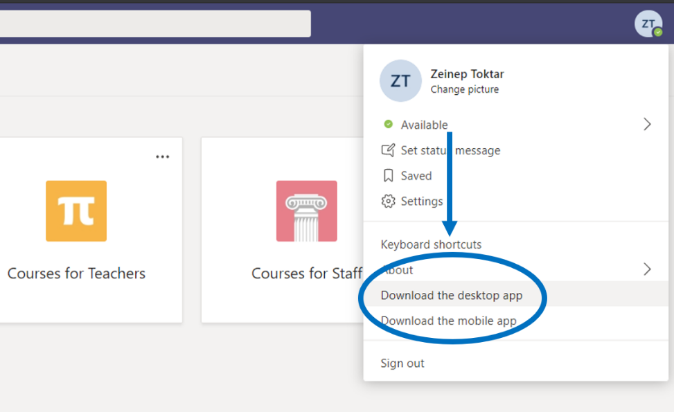
Picture 3: Installing a PC application
- Sign in through a mobile application: On your mobile device, download the application to the App Store or Google Play. Touch the Teams icon to start. Then log in using your username and password.

b. Teams interface:
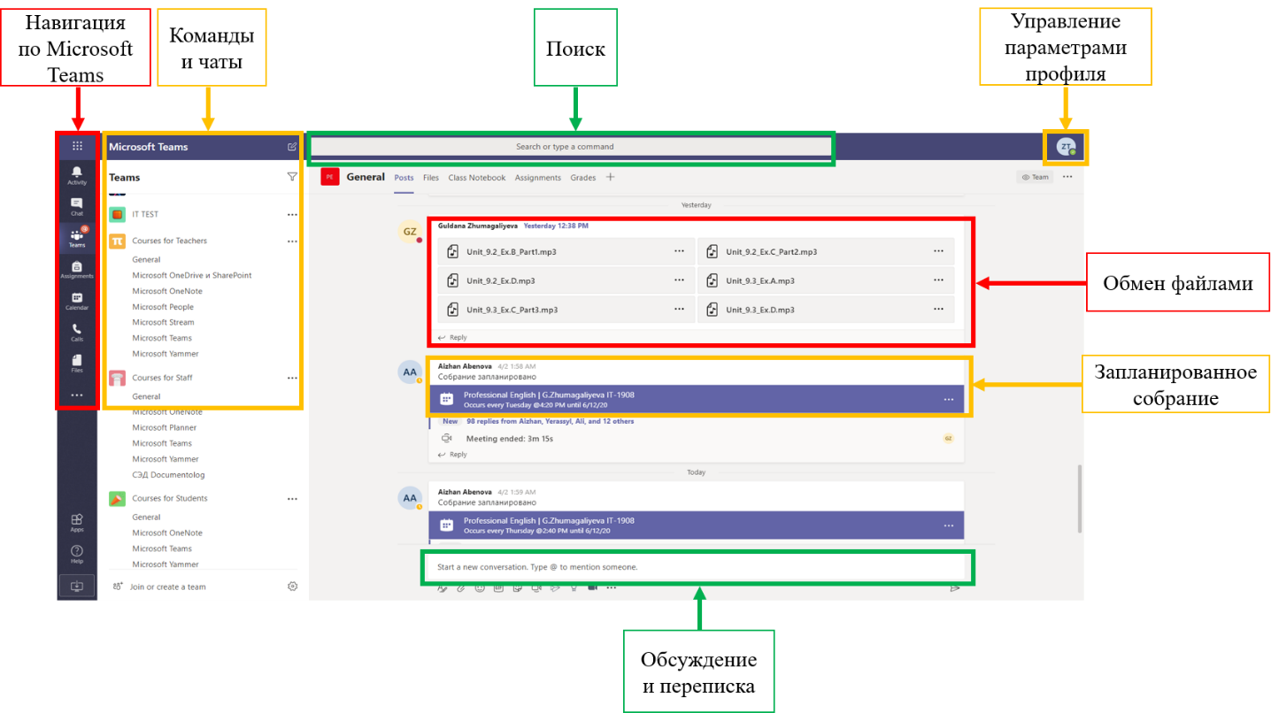
Picture 4: Teams interface
The main panel for navigation through Microsoft Teams is located on the left vertical. From top to bottom: Actions, Chat, Teams, Calendar, Calls, Files, Application Search, Adding Applications, Help.
In the area next to the navigation panel you can view available commands and chats.
In the "Search" field, you can search by specific items or users.
You can use the "Manage Profile Settings" feature to change application settings, photo, or download the application.
The chat interface consists of the following buttons (from left to right): "Format", "Attach", "Emodsi", "GIF", "Stickers", "Hold a meeting", "APTS".

Working with Microsoft Teams
c. Creating a "Team"
Go to the "Commands" menu and click "Create command":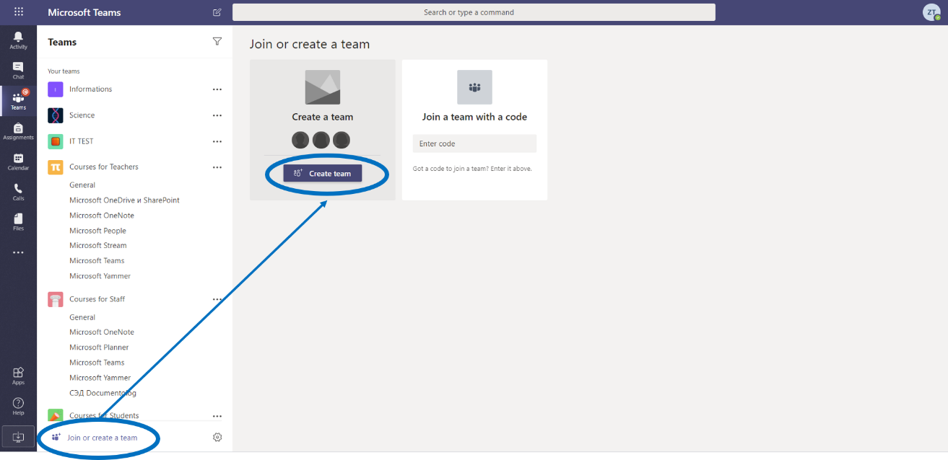
Picture 5. Create a team
Select "Classes" from the available options: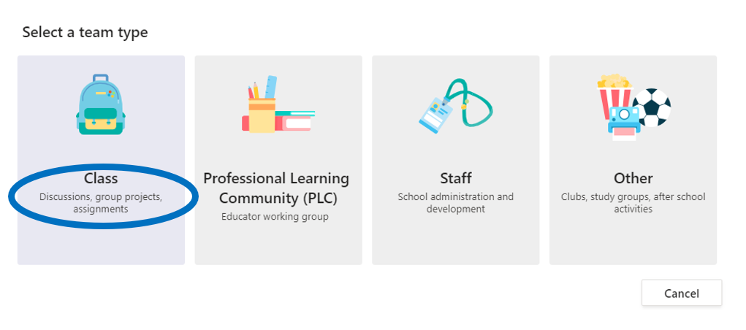
Picture 6. Create class
Enter the name of the team:
Picture 7: Specify class name
Add students and the right teachers:
Picture 8. Add students and teachers

The team is created. Now you can communicate and work within the team.
Note that Students are added as "Participants" of the team and Teachers as "Owners".
The table below shows the difference in permissions between the Owner and Participant:

Table 1. Opportunities for the Owner and Participant
Actions | Team Owner | Team Participant
Team building | Yes | No
Leaving the team | Yes | Yes
Change the name and description of the command | Yes | No
Deletion of the team | Yes | No
Adding participants | Yes | No

d. Confiture the command
In this menu you can manage the command: change the name of the command, add and delete participants and assign roles, create new channels or get links to the command:
Picture 9. Configuring the command
e. Planning a team meeting
To create a meeting, click "Create meeting" below the message entry area:
Picture 10. Start a meeting
Then click "Schedule a meeting" to include it in your future event schedule: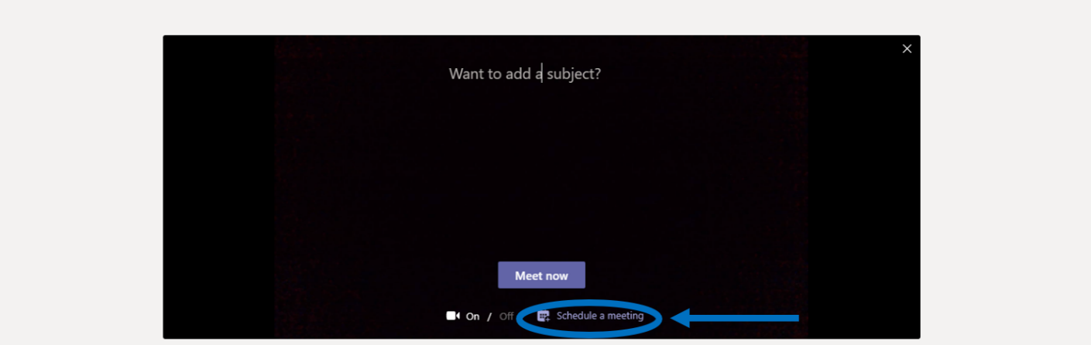
Picture 11. Schedule a meeting
In the window that appears, fill in the necessary information about the meeting: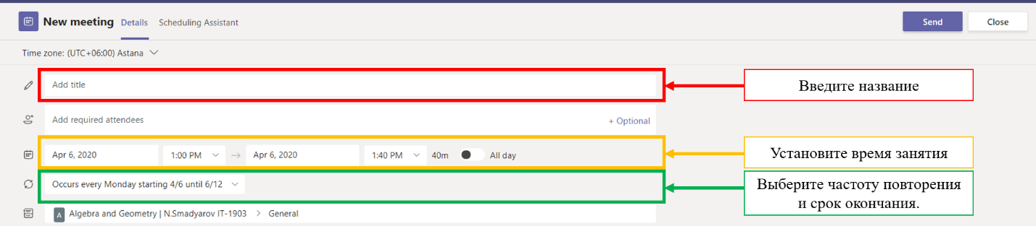
Picture 12. Filling in meeting data
Then you need to click "Send", so that participants of the channel will receive invitations in their calendar.
f. Joining meetings
Keep track of meeting invitations in your team channel or in your Teams calendar:
Picture 13. Invitations to a team meeting
Click on the invitation and click "Join" to join the meeting.
Check the audio and video input, turn on the camera and microphone. Select "Join" to participate in the meeting:
Picture 14. Join the meeting
g. Participation in meetings
Share video, talk and show your screen during an online call: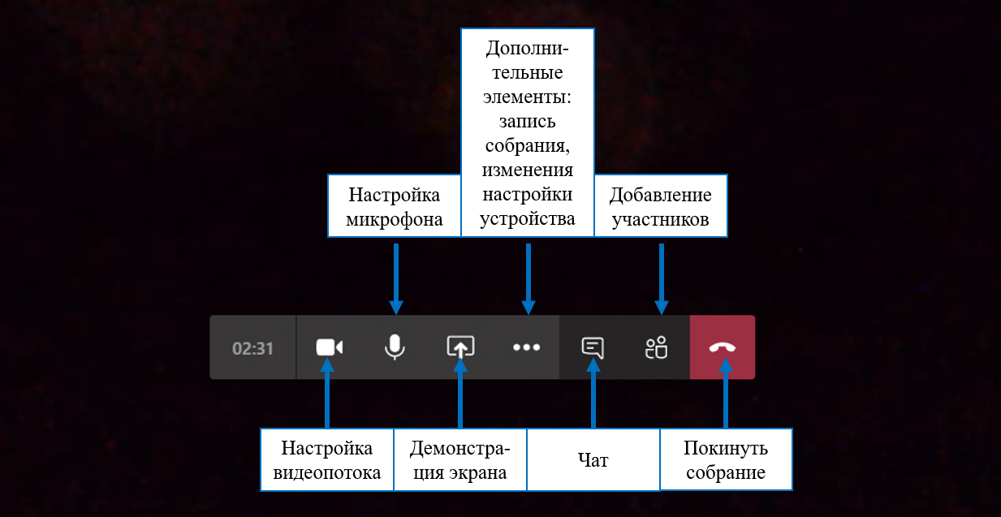
Picture 15. Participation in the meeting

3. Additional features of Microsoft Teams

a. File exchange
Click "Attach" under the message entry field, select the path to the file, and then the file itself. Depending on where the file is stored, you will be prompted to upload a copy, share a link, or something else.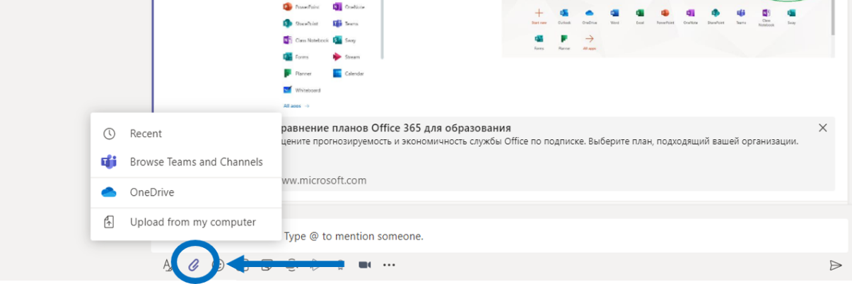
Picture 16. Attach files
b. Adding a tab to the channel
Click "+" next to the tabs at the top of the channel, select the desired application, and then follow the prompts. Use Search if you can't see the application you need: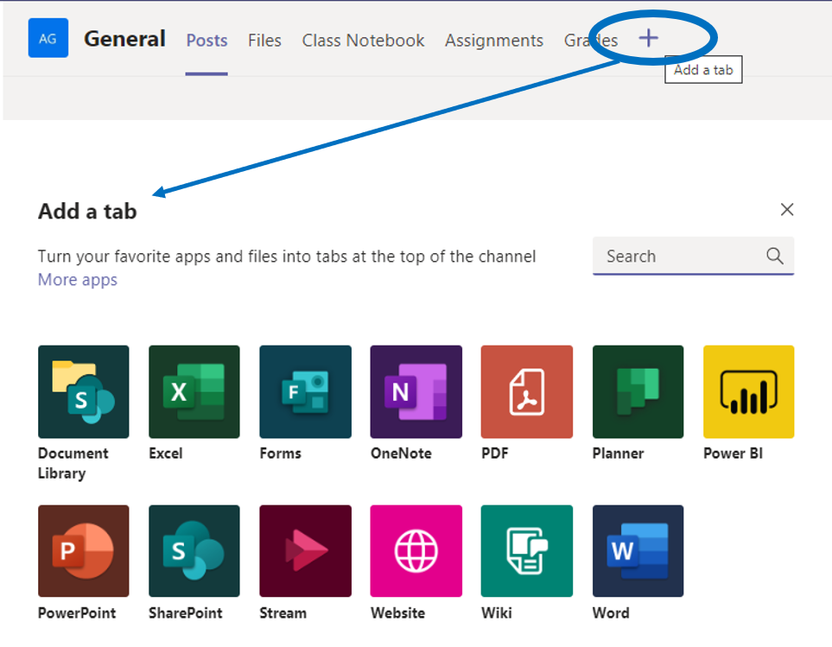
Picture 17. Add tabs
c. Adding an application
Click on "Applications" on the left. Here you can select the applications you want to use in Teams, set the desired settings and "Add":
Picture 18. Add applications

If you have any questions, you can always contact support at http://helpdesk@astanait/edu/kz /.

Instructions on how to use Moodle for DET training at Astana IT University

LMS Moodle and basic application features

LMS Moodle training courses include a set of information materials used to create a theoretical foundation for the course (text documents, presentations, Web links, multimedia materials), knowledge control materials (usually automated tests or tasks), as well as materials for communication and interaction with the instructor (forums, chat rooms, messaging, etc.).

In Moodle's maintenance system, teaching and learning materials are available electronically to students, which consist of:

- the working curriculum of the discipline (sillabus);

- educational and methodical materials containing theses of lectures, plans of seminar sessions, laboratory workshops, tasks of SRS and SRS;

- multimedia presentations;

- electronic educational publications;

- links to ready-made electronic content on topics (if available);

- references to the recommended literature;

- the schedule of assignments by discipline;

The following is a detailed instruction for participants on how to use the Moodle platform resources.
Log in to the system
Login to the Astana IT University Distance Learning site by following the link: http://moodle.astanait.edu.kz/.
The main page of the site is shown in the picture: 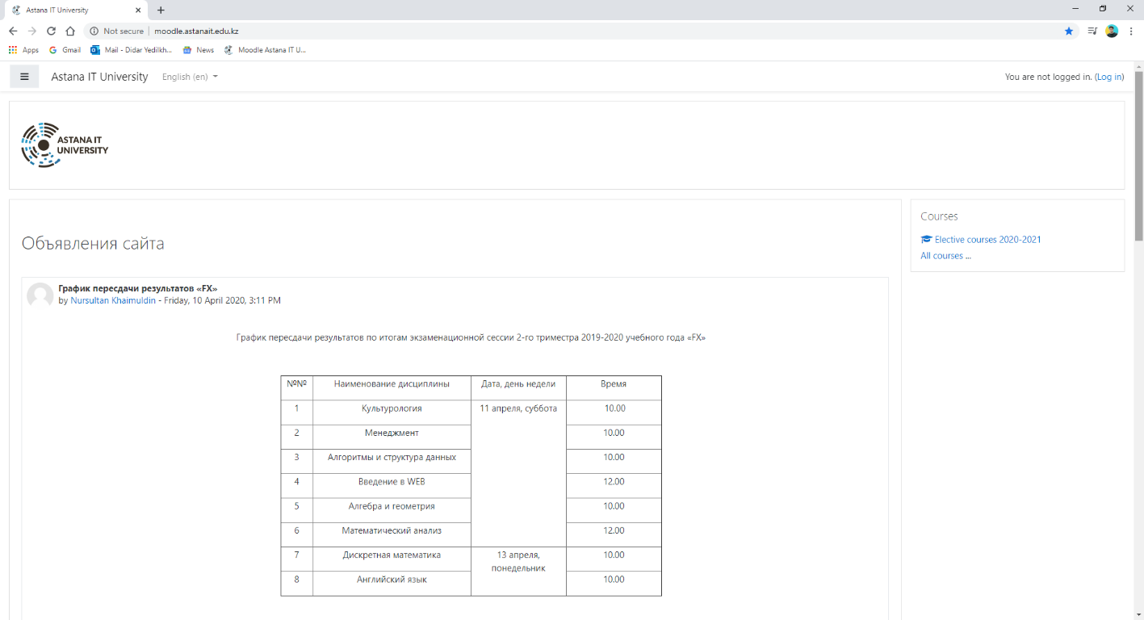
To log in, you need to log in by clicking the Log in button located in the upper right corner of the page. Next, you need to specify the user name that is created for each student by the platform administrator: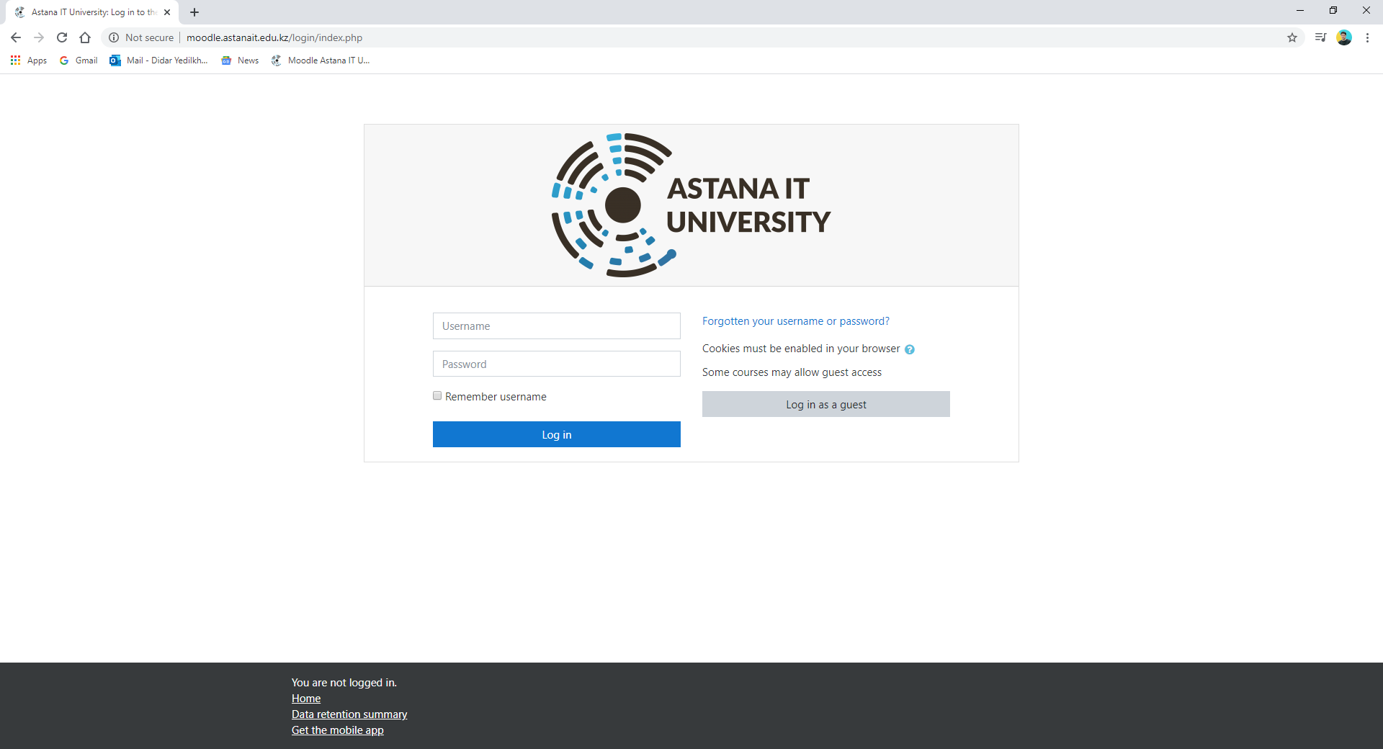
This will open a personal page containing general announcements of the university, the choice of the interface language, and a list of available courses (Course Summary - My Courses - located on the right side of the page).
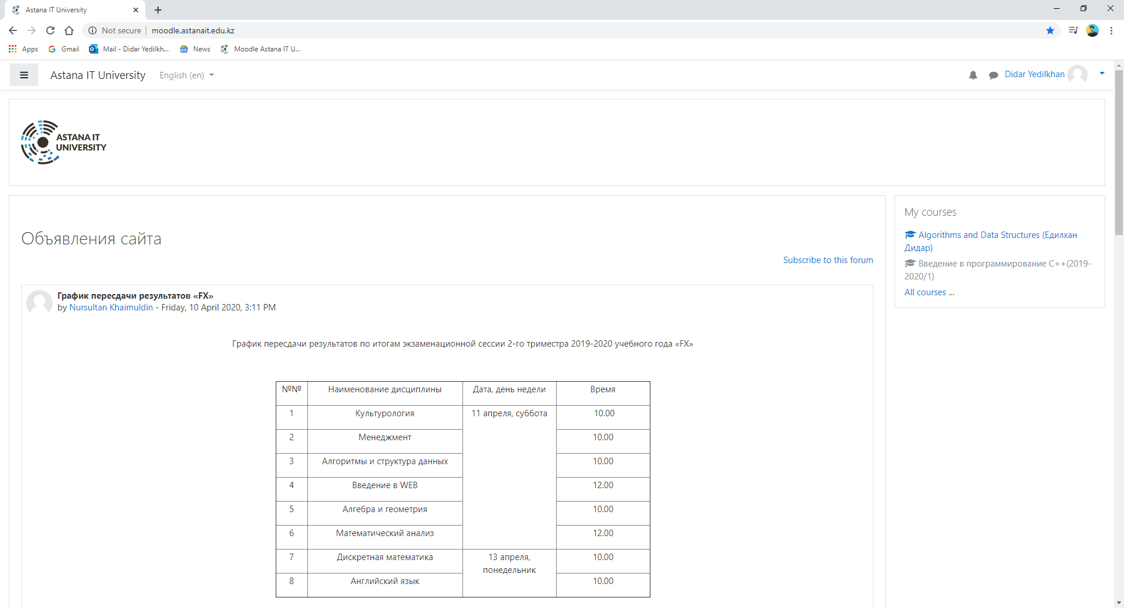
Click on the link containing its name to access the course content. The selected course page and the instructor assigned to the course will then be opened. This page contains announcements for a particular course, the course syllabus, the ability to view student attendance, and other information that is important for the particular course.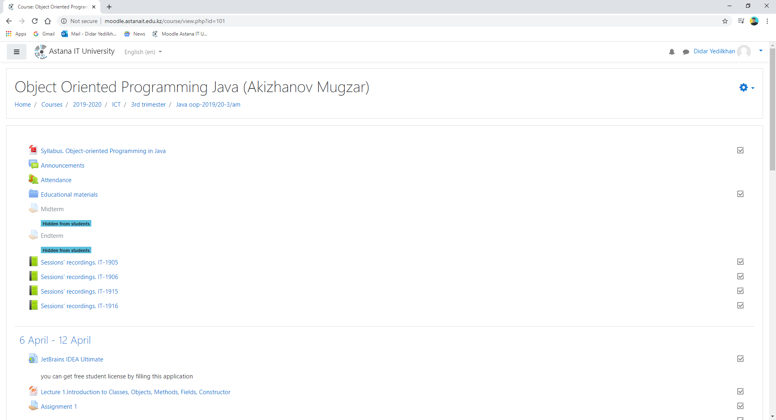
Each course is structured by sections or topics (the course is structured by weeks - only 10 weeks of training (trimesters)). Each section, as a rule, contains theoretical material for studying, additional materials, as well as materials for knowledge control. After you open the course, you will have access to the following:
1. Study materials that the instructor has placed for the course/group. These may be downloadable files, audio or video presentations, links to web pages, or plain text; each type of learning material has its own picture;
2. Actions - tasks that the instructor has planned and that you will need to complete by a specific deadline; each type of activity has its own title;
3. "Upcoming Events" Course - here you can see both the lectures and the activities planned by the instructor, which should take place in the near future.
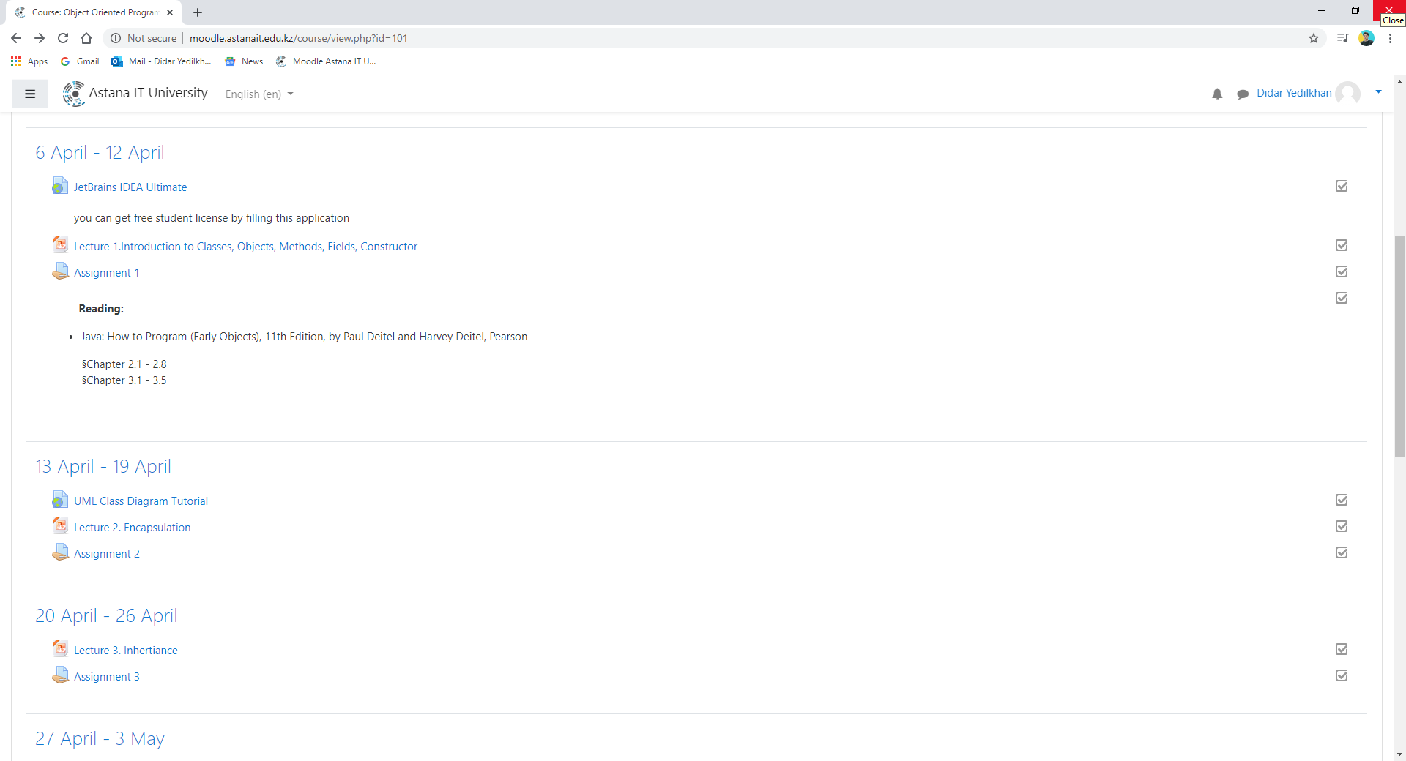
2 Integration with Moodle teams
The faculty has the ability to make links to recommended sites on its page, for example, for Microsoft Teams.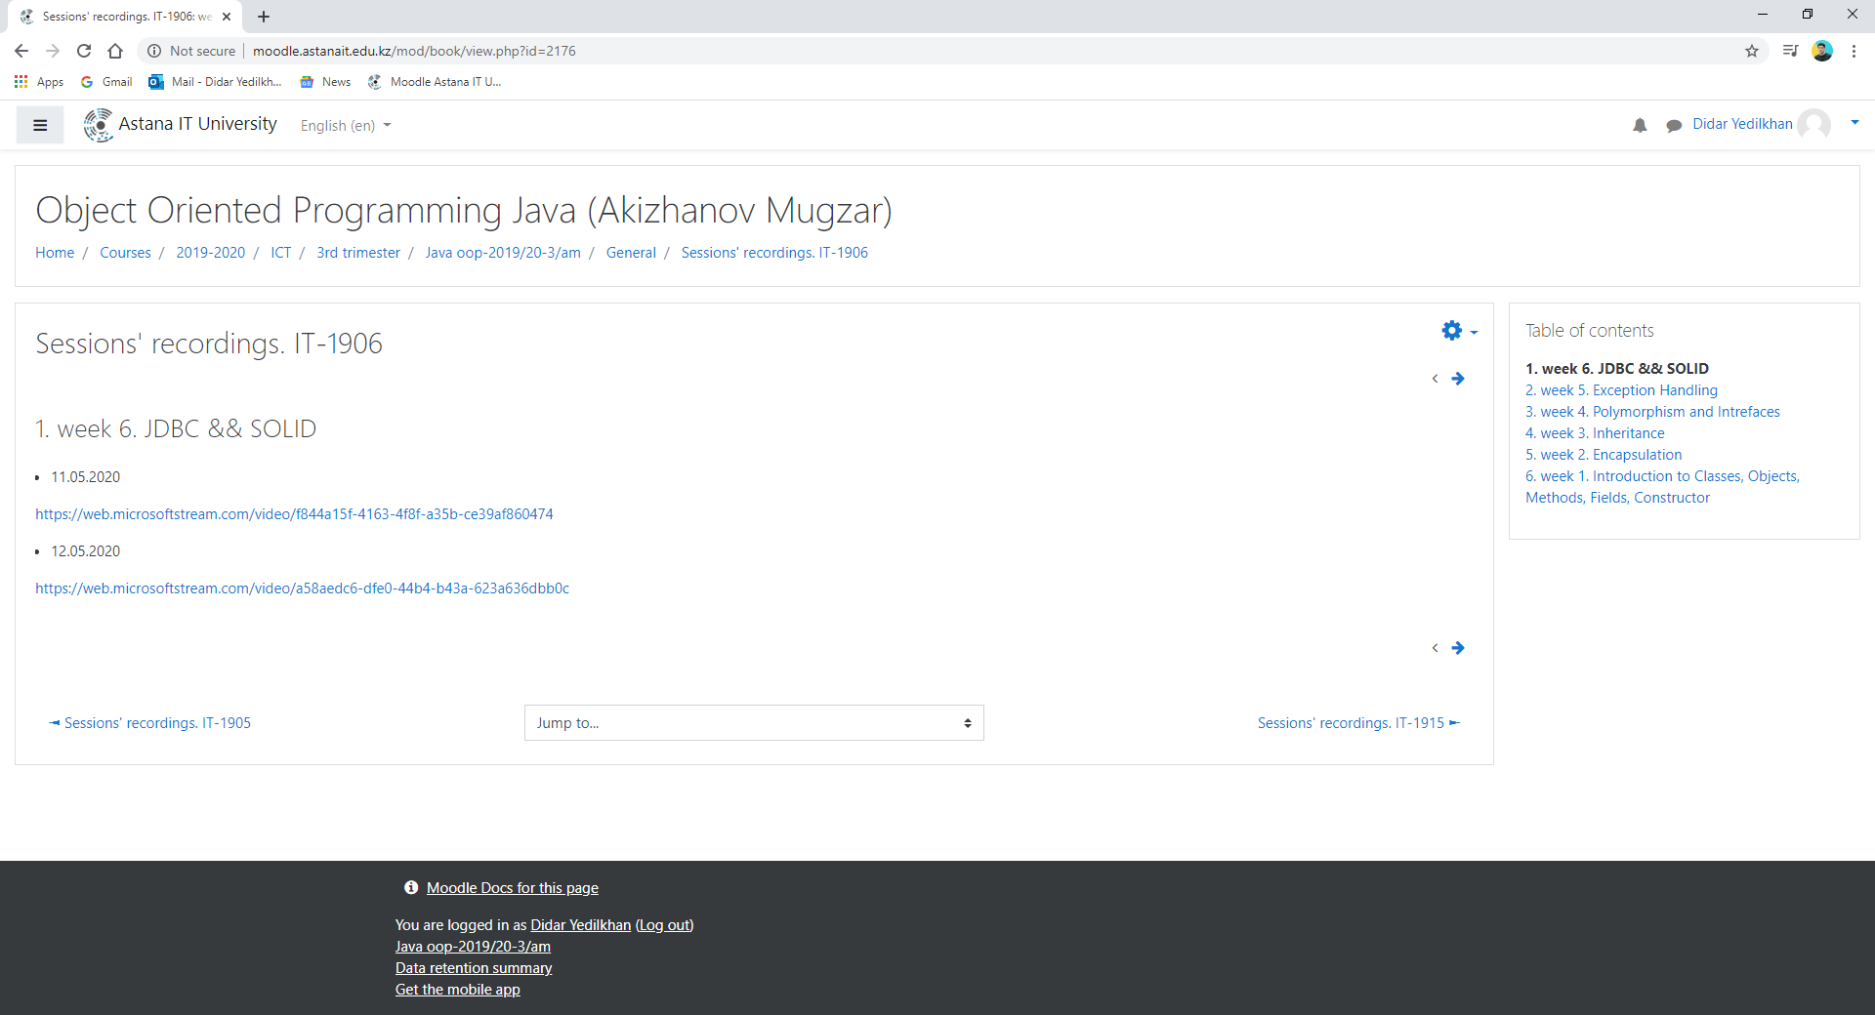
When the link is activated, the Microsoft Stream platform page opens, where the instructor places a video lecture with Microsoft Teams recorded in the lesson. 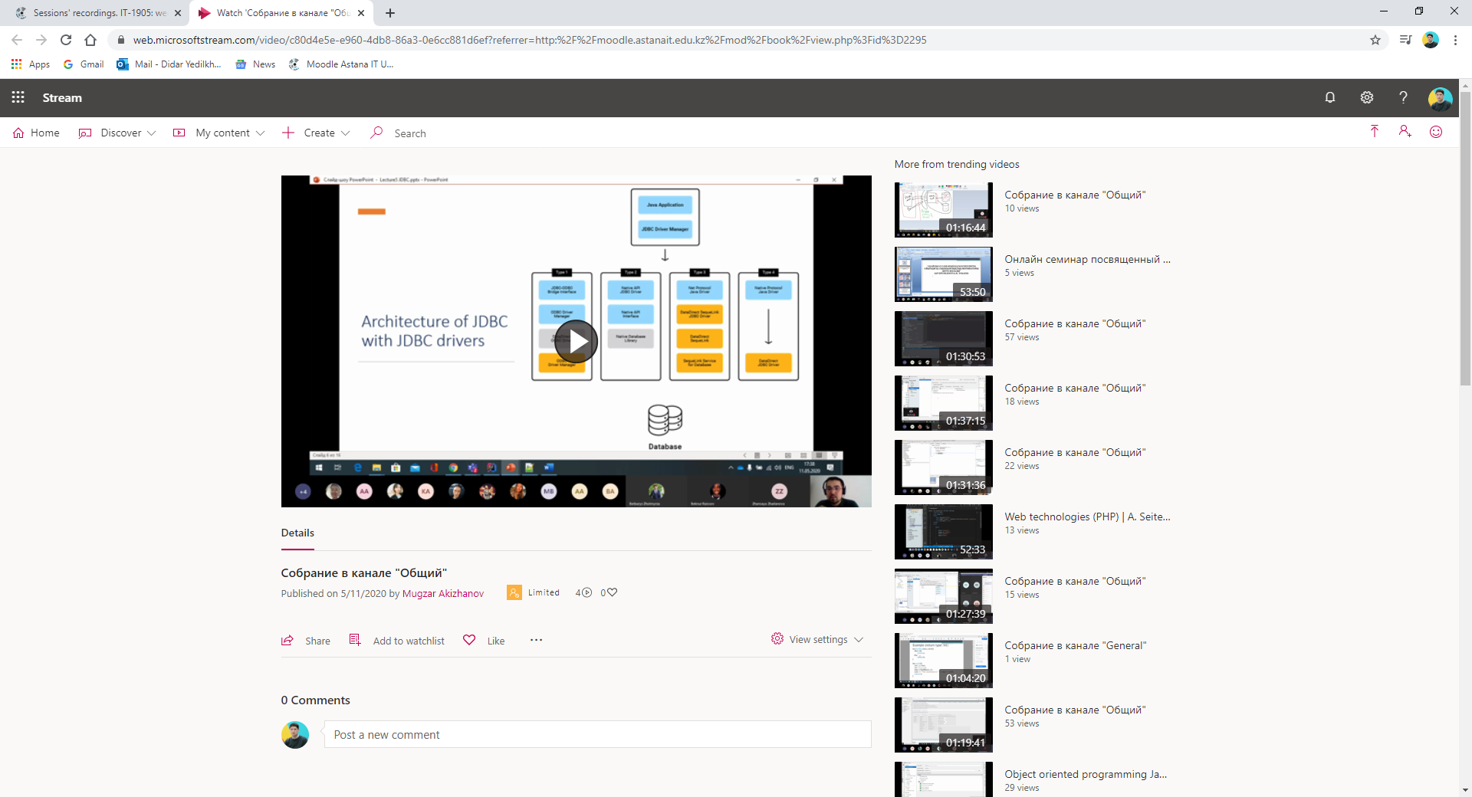
Students can download the lectures by clicking on the "Download" button, and if necessary, save them to the desired folder. 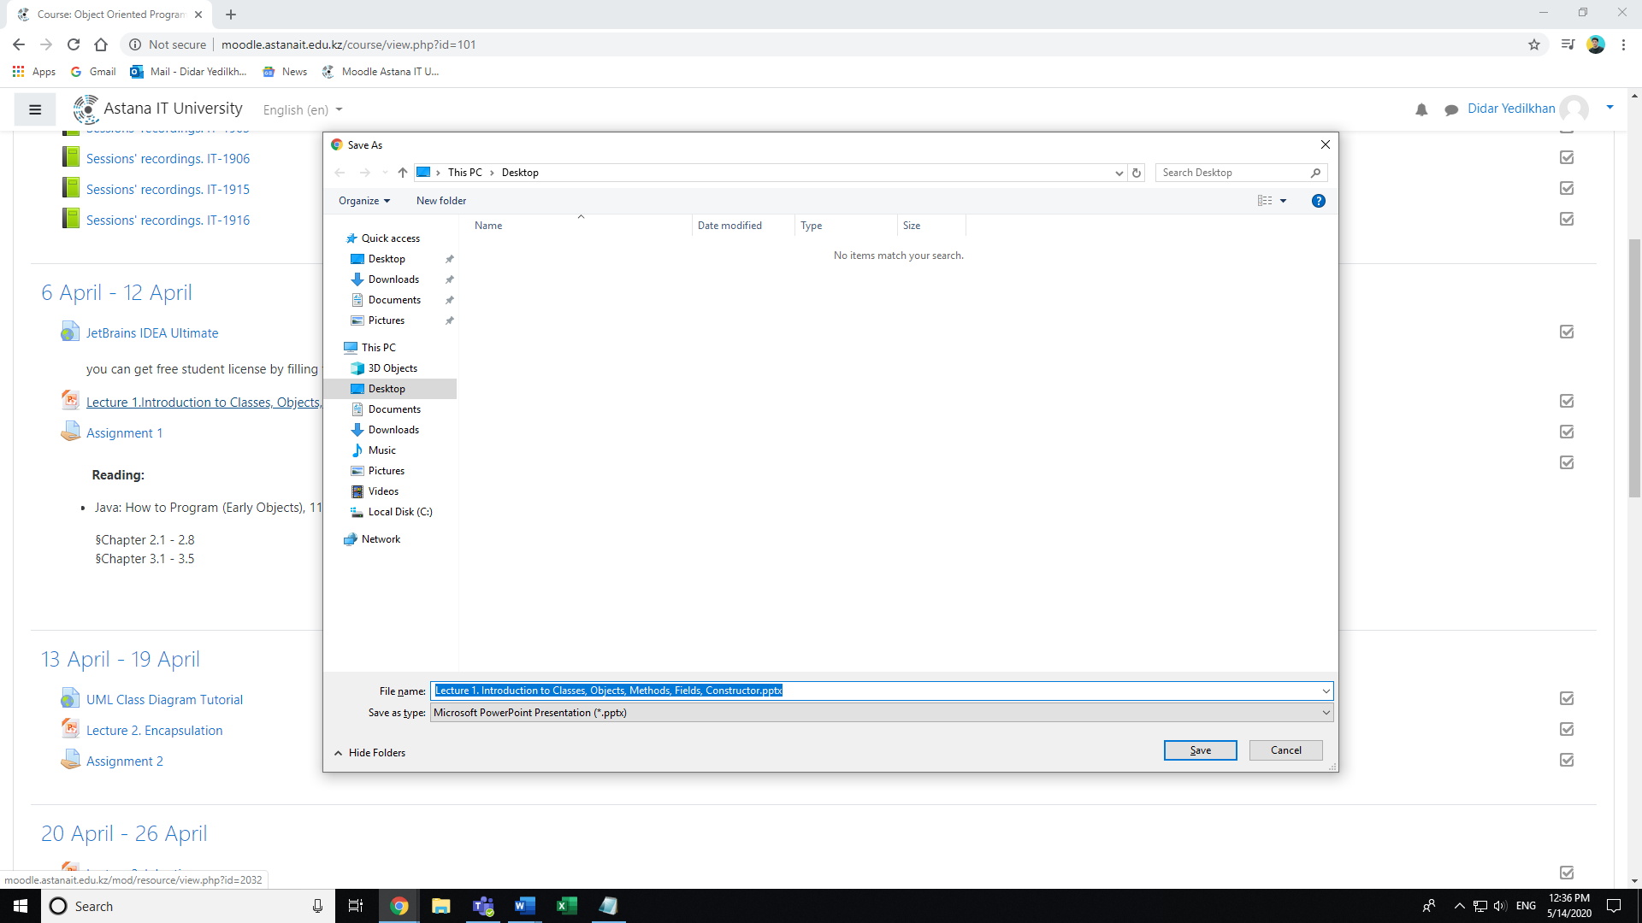
The faculty on the page of a particular course may place video lectures or additional video materials. It is important to note the possibility of using video from the portal Youtube.com. Integration of Youtube.com with Moodle does not require any additional switching to Youtube.com or downloading video material.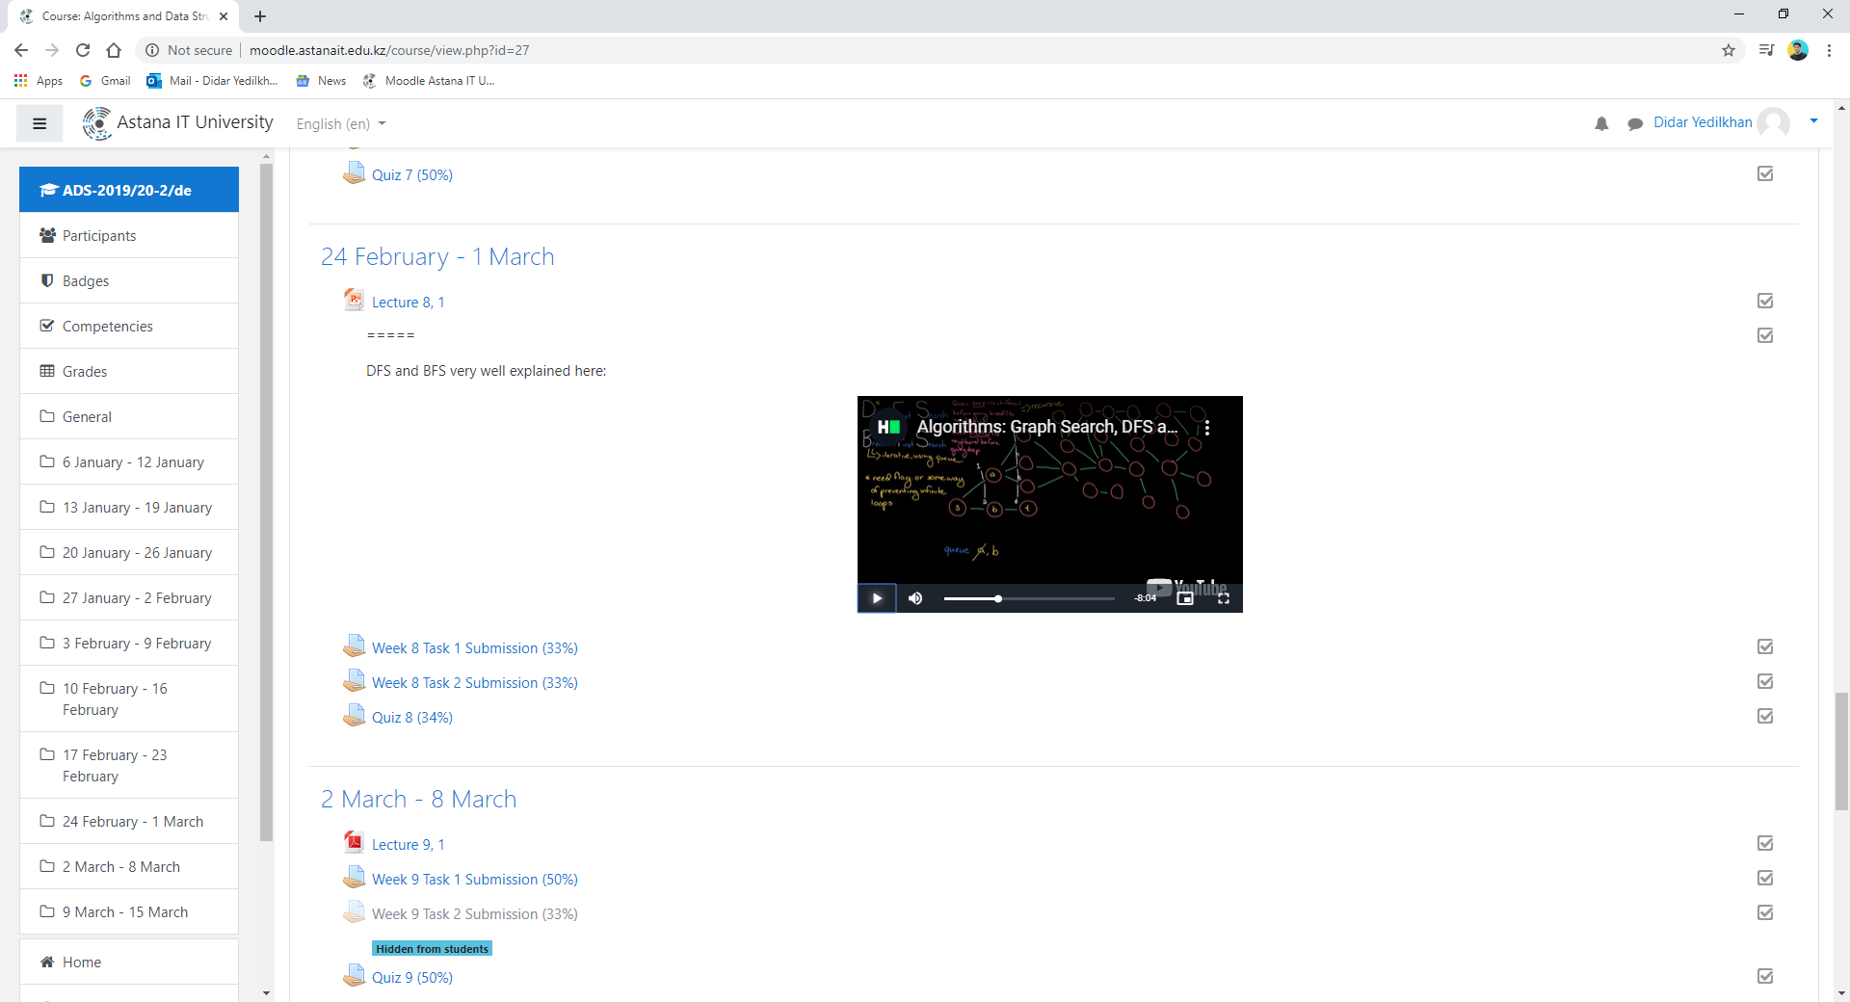

On The faculty page you can see the result of the students' tasks, including the task itself (Assignment 1.docx) and the number of completed tasks.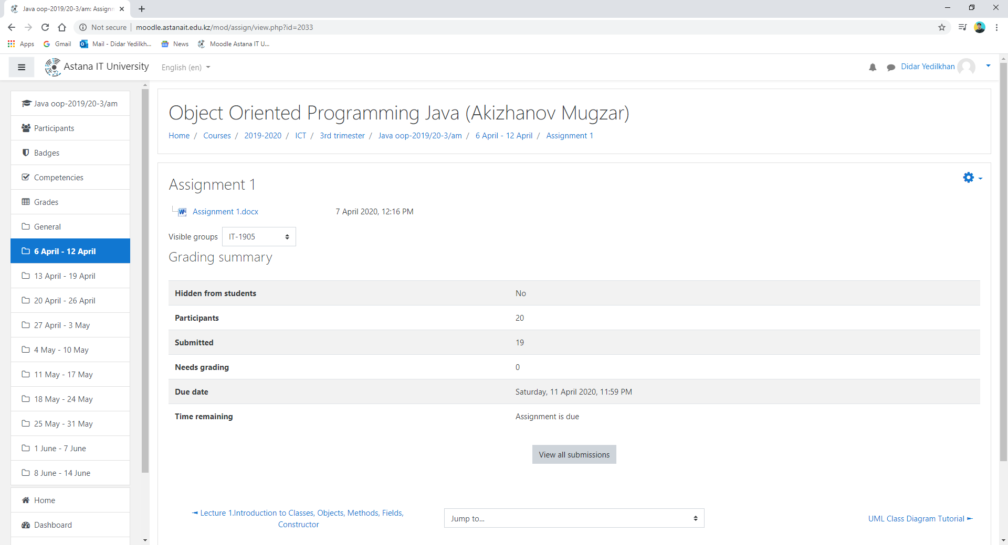
In case the task is an automatic test with multiple answers, the student can come to this test and see in which questions he made mistakes: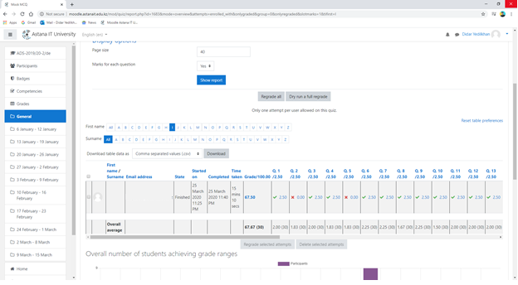
3. Rating in Moodle
Once you have completed your grades, you will see the grades for all students in the course.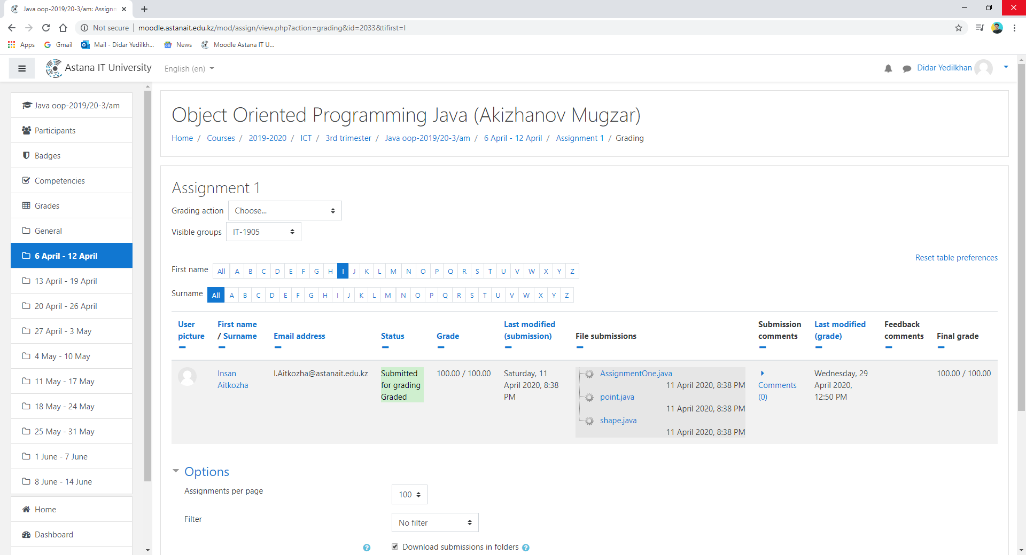
Students have the opportunity to view a summary table of all grades, in order to do so, in the upper left corner (near the university logo), you must open the menu and select "Grades", in which case you will see a summary of all grades for the course, including the percentage of attendance, as shown below: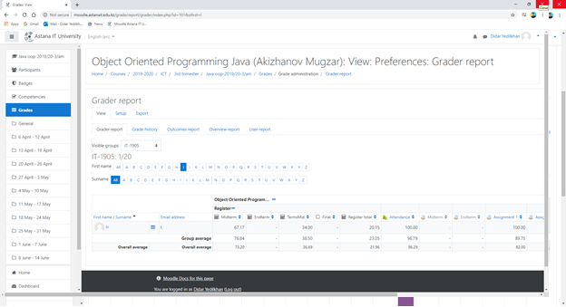
In addition, the faculty may conduct a class quality analysis through a student survey as shown below: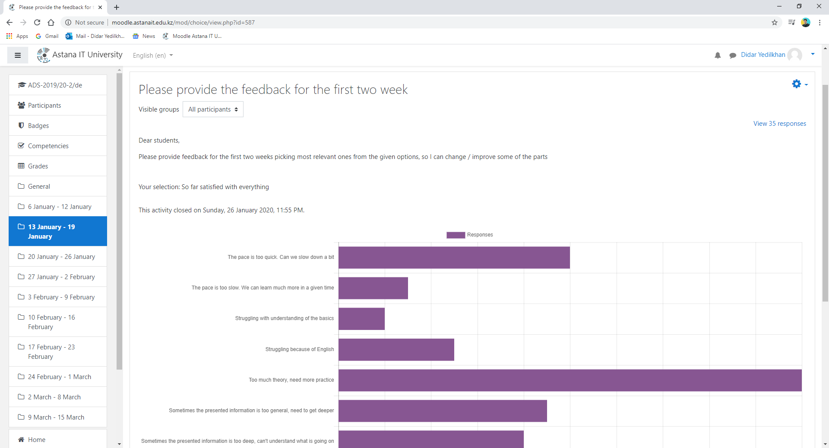

If you have any questions, you can always contact support at http://helpdesk@astanait/edu/kz /.

AITU LIBRARY

The scientific library is an important information, educational and cultural center of the University.
It organizes library, reference and bibliographic and information activities.
It provides with information the current educational, research, educational processes, creating conditions for continuous acquisition and updating of knowledge focused on the needs of scientific, technical, spiritual and moral development.
The scientific library is located on the 1st floor. The total area of the library is 1203.01m.
Library and information service of the faculty and students of the University is carried out on a season ticket, in the reading room for 250 seats. The library is divided into convenient zones, comfortable conditions for work in the library are created. It is equipped with modern computer hardware and software, 51 computers with Internet access have been installed, the WI-FI zone has been opened, which provides access to Internet resources. Work with laptops, educational CD and DVD editions is provided. There is access to full-text electronic resources of the Republican Interuniversity Digital Library (RINEB), SCOPUS, ScienceDirect, Web of Science, Elsevier, etc.
The scientific library has a sufficient book collection, including educational, methodological and scientific literature on general, basic and profiling disciplines on paper and electronic media.
The book fund is 10,076 copies, 6054 of which are in the state language, 267 are on electronic media. Available database of e-books EBSCO - 73872 units, e-books RIEW - 41921 units. There is access to the database within the framework of the National subscription: Elsevier, Scopus, Science Direct, Web of Science. 9 Open access database: zbMath, DOAJ, Openu.kz, ASEE, Mendeley, Google Education, Annual Reviews, ArXiv.org, DOAB.
6 electronic libraries with open access: National Electronic Library, Kazakhstan Open Library kitap.kz, Cyberleninka, Adebiportal.kz, Electronic educational literature kasipkor.kz, Virtual Library of Innovative Educational Technologies (Hiedtec.ecs.uni-ruse.bg).
The fund is being updated in accordance with the educational programs of the University, electronic resources are being expanded and subscription to periodicals is being conducted.
Purchases are made from well-known domestic and foreign book trade networks, publishing houses, information institutions, companies.
The scientific library actively participates in national and international conferences, seminars, exhibitions, book fairs and other cultural events.
In the reading rooms are decorated exhibitions of new literature, thematic open views of publications from the library, as well as views of the jubilee and significant dates.
In the hall of electronic resources is provided access to subscription databases (DB), which are provided to the University in accordance with contracts concluded for a certain period on a paid or free basis. Subscription DBs are specialized databases of text and other information with a specific purpose and are divided into legal, scientific, reference and searchable, online magazines, full-text or bibliographic and others.

STUDENT SUPPORT SERVICES
Dean's office: office number C1-322, telephone 8(7172)64-57-06, e-mail: muslim.sergaziyev@astanait.edu.kz. Carries out planning, organization, monitoring, analysis and perfection of educational, methodical and educational work; organization of educational process on the basis of innovative technologies and methods of training, estimation of educational achievements in the context of student-centered training, teaching and estimation.
Student Department: office ¹ C1-270, telephone 8(7172) 64-57-07, e-mail: madina.mukaliyeva@astanait.edu.kz. Carries out the formation and maintenance of personal records of students throughout the student "life cycle". Keeps records of the contingent of students by age, sex, place of residence (region), nationality, terms of payment (for educational grant, grant of IOI, grant of enterprise’s, organizations, on a paid basis), social status.
Office of the Registrar of the University: office number C1-273, phone 8(7172) 64-57-07, e-mail: aliya.koitanova@astanait.edu.kz. Carries out registration of history of educational achievements of students during the whole period of study. It accompanies the educational process on credit and distance educational technologies.
Department on work with students: office No. C2-245, phone 8(7172) 64-57-09, e-mail: aidos.kassymov@astanait.edu.kz Carries out creation of information-educational and sociocultural environment favorable influencing on formation and development of personality of future specialist. Engaged in providing conditions for the disclosure and self-realization of the creative potential of student youth, organization of student leisure, support for student creative and sports clubs and groups.
Scientific Library: office number C1 - telephone 8(7172) 62-57-17, e-mail: aiman.amangeldiyeva@astanait.edu.kz. Provides assistance to the scientific and educational activities of the university. Develops information functions, accumulates third-party and creates its own information resources, provides access to national and world information networks. The main information about the work of the scientific library is available on the Web-site (https://astanait.edu.kz/library/), which provides an electronic catalog, bulletin of periodicals and other information necessary for students.
Department of Academic Affairs: office number C1-264, phone 8(7172)64-57-07, internal 2020,2021 e-mail: ainur.bakenova@astanait.edu.kz. Carries out planning, organization and control of the educational process of the university, implementation of innovative technologies of education.
Department of Science and Innovation: office number C2-155, telephone 8(7172)64-57-13, e-mail: Sholpan.Borashova@astanait.edu.kz. The Department carries out planning, coordination and organization of scientific and innovative activity; development of perspective forms of cooperation, including international, with IT-companies and branches of economy for joint solution of scientific problems and use of scientific developments.
Department of International Cooperation: office number C1-333, telephone 8(7172) 64-57-08, e-mail: Leila.Salykova@astanait.edu.kz. The main task of the Department is to develop international relations with foreign higher education institutions and scientific organizations, with leading IT companies and other international organizations and associations, as well as to strengthen the internationalization of education.
Career and Employment Center: office number C1-272, gulzhan.soltan@astanait.edu.kz sets the task of forming career skills of students and graduates, as well as promoting employment of graduates. It organizes professional practices for students.
Competence and Excellence Center (CEC): Office No. C2-135, telephone 8(7172) 64-57-14, e-mail: sapar.toxanov@astanait.edu.kz. Provides "Digital MBA - EMBA" training for commercial and public sectors, organizes training and certification for educational programs of additional/non-formal education of children and adults in IT-technologies and related spheres.
Department of Marketing and Public Relations: office number C2-368, phone 8(7172) 64-57-18, e-mail: Dastan.demeugazyyev@astanait.edu.kz. Develops a marketing strategy. Interacts with mass media, public organizations for timely informing the public about the most important events in Astana IT University activities.
Quality Assurance Department: office number C1-328, telephone 8(7172) 64-57-27, e-mail: Adil.Faizullin@astanait.edu.kz. Carries out the formation of internal quality assurance system and quality management system; ensuring the licensing of educational activities.
General management of the student support service is carried out:
Omirbayev Serik Maulenovich, Doctor of Economics, Professor, phone: 8(7172)64-57-22, internal 2019 e-mail: serik.omirbayev@astanait.edu.kz.

“Astana IT University” LLP
Extract from the Rules
Internal and work regulations

- General regulations

1.1 These rules of internal regulations of "Astana IT University" LLP are developed in accordance with the Labour Code of the Republic of Kazakhstan, the Law of the Republic of Kazakhstan "On Education", the Charter of "Astana IT University" LLP (hereinafter - the Partnership) and other legal acts.
1.2. The rules determine the work schedule of the Partnership, the procedure for hiring and dismissing employees, the legal position of the parties to the employment contract, working hours, rest periods, incentives and penalties applied to employees, educational discipline for students of the Partnership and other issues of employment relations.
1.3. Labor and training schedule - rules of conduct of employees and trainees both during work (training) and other periods of stay on the territory of the Partnership, i.e. in buildings, structures, premises, land plots and other objects belonging to the Partnership.
1.4 The employees of the Partnership, which are subject to these Rules, include all categories of persons working in the Partnership under an employment contract and holding positions of professor-teaching, administrative and managerial personnel, service personnel, training and auxiliary and other personnel according to the staff schedule approved in the established order, or performing work in a particular profession, specialty (with indication of qualification), or hired to perform a particular type of work.
1.5. All persons enrolled in the established order in the Partnership as students, trainees, master's students for training in basic educational programs on the basis of the government educational order and on a paid basis.
All categories of students shall enjoy equal rights, have equal duties and responsibilities, unless otherwise provided by the legislation, the Charter of the Partnership and other regulatory legal acts.
1.6. The Partnership Administration represented by the Rector or an official authorized by the Rector shall act as an employer in relations with employees of the Partnership, and as persons organizing and controlling the educational process.
1.7. Labor activity of employees of the Partnership is aimed at achievement of goals and objectives set out in the Charter of the Partnership. Rights and obligations of employees and administration of the Partnership within implementation of their educational, scientific and other activities are defined in regulatory acts on labor, education, science, the Charter of the Partnership, these Regulations and other local regulatory acts.
1.8. Labour and academic discipline shall be ensured by creation by the Administration of the Partnership of necessary organizational and economic conditions for normal high-performance work, conscious performance of labour and academic duties, methods of persuasion, education, as well as rewards for conscientious work and education. Disciplinary sanctions shall be imposed on those who violate the discipline.

7. 7. Teaching order, rights and obligations of students

7.18. Each group shall appoint a headmaster from among the most advanced and disciplined students.
7.19. The head of the group reports directly to the dean and conducts all of the group's orders and instructions.
7.20. The functions of the head of the group are the responsibility of the head of the group:
7.20.1. personal record of students' attendance at all types of classes;
7.20.2. submission of information to the dean's office regarding the absenteeism or tardiness of students in classes with reasons for the absenteeism or tardiness in the form and within the time frame set by the dean's office;
7.20.3. observation of the government of the academic discipline in a group at lectures and other classes, as well as the preservation of academic equipment;
7.20.4. timely organization of receipt and distribution of textbooks and teaching aids among the group of students;
7.20.5. notification of students about changes made to the schedule of classes, place and time of tests, examinations, industrial practice, announcements, dean's orders, and events held in the Partnership.
7.21. The head of the group has the right:
7.21.1. demand that the students of their group execute the orders of the dean's office and the curators;
7.21.2. In the event of conflicts or problems related to education, contact the curator or the dean's office for explanations on all issues;
7.21.3. renounce their duties by offering a successor in their place.
7.22. The head of the group keeps a log of student attendance, with the students being introduced to it against their signature.
7.23. The group has the right to apply for re-election of the head of the group by submitting a collective application to the dean's office, specifying the reason and proposing a new candidate.
7.24. The students have the right to:
7.24.1. to receive quality education in accordance with the government compulsory education standards;
7.24.2. choosing alternative courses in accordance with the curricula;
7.24.3. obtaining additional educational services, knowledge according to their inclinations and needs on a paid basis;
7.24.4. participation in the management of the educational organization; 7.24.3. obtaining additional educational services according to their inclinations and needs on a paid basis; 7.24.4;
7.24.5. restoration and transfer from one educational institution to another, from one specialty or higher education programme to another, from paid basis to government educational order or from one form of education to another;
7.24.6. Free use of information resources in educational organizations, including in an accessible form for the disabled, children with disabilities, provision of textbooks, educational and methodical complexes and teaching aids, including those made for the disabled, children with disabilities;
7.24.7. Free use of sports, reading, assembly halls, computer classes and library;
7.24.8. Receiving information on the employment situation in accordance with the legislation of the Republic of Kazakhstan;
7.24.9. Free expression of own opinion and convictions;
7.24.10. Respect for your human dignity;
7.24.11. Receipt of encouragement and remuneration for success in studies, scientific and creative activities;
7.24.12. Preferential travel by public transport (except taxi) by decision of local representative bodies;
7.24.13. Deferment of call-up for military service in accordance with the legislation of the Republic of Kazakhstan.
7.25. The Student Partnerships are obliged:
7.25.1. Master knowledge, skills, practical skills and competencies in accordance with the requirements of the government mandatory education standard;
7.25.2. comply with contractual obligations under the Agreement on provision of educational services;
7.25.3. attend mandatory training sessions and perform all types of tasks stipulated in the study plan and programmes in due time;
7.25.4. to undergo intermediate and final attestation of knowledge in accordance with the study plans, programmes and academic calendar within the established term;
7.25.5. to take part in the public life of the Partnership;
7.25.6. respect the honour and dignity of the teaching staff, traditions of the Partnership;
7.25.7. take care of their health, strive for spiritual and physical self-improvement;
7.25.8. Observe the rules of military registration;
7.25.9. Observe etiquette in choosing and wearing clothing during training in the Partnership;
7.25.10. Treat the property of the educational establishment with care and care (teaching aids, books, devices, inventory, etc.). Trainees shall not take out various equipment from educational and other premises of the Partnership without the permission of the administration. In case of material damage caused to the Partnership, students shall be obliged to compensate it in accordance with civil law;
7.25.11. comply with safety and fire safety rules;
7.25.12. comply with these Regulations and rules of living in rented housing provided by the Partnership;
7.25.13. comply with other requirements stipulated by the Charter of the Partnership and the Agreement on Provision of Educational Services.

8. Encouragements and success in learning
8.5 The following rewards shall be awarded to the Partnership for Students for good performance, sporting achievements, active participation in research work and social life:
8.5.1. declaration of gratitude;
8.5.2. awarding with certificates;
8.5.3. rewarding with a valuable gift;
8.5.4. awarding a scholarship;
8.5.5. a discount on tuition fees;
8.5.6. transfer to the Rector's grant,
8.5.7. transfer for a scholarship of the President of the Republic of Kazakhstan;
8.5.8. personal scholarships.
8.6. The scholarships are announced by order of the Rector, brought to the attention of students and entered into the personal file of the student.
8.7. A memo on application for incentive measures is initiated by the coordinators and dean of the Partnership.

9. Responsibility for violation of academic discipline
9.7. The following types of disciplinary sanctions may be imposed on students for violation of an academic discipline (including failure to attend classes without a valid reason), these Rules (committing immoral acts by a student: appearance in a government of alcohol or drug intoxication, violation of public order, etc.):
9.7.1. remark;
9.7.2. reprimand;
9.7.3. strict reprimand;
9.7.4. eviction from the residential premises - termination of the residential premises lease agreement;
9.7.5. bringing to liability persons who caused material damage to the property of the Partnership;
9.7.6. exclusion from the Partnership.
9.8. Disciplinary punishment in the form of remark, reprimand, strict reprimand and termination of residential premises lease agreement is imposed by the Disciplinary Council.
9.9. Disciplinary punishment in the form of exclusion from the Partnership shall be executed by order of the Rector.
9.10. The basis for disciplinary punishment is the decision of the Disciplinary Council to which it is attached:
9.10.1. explanation of the student who has committed a disciplinary offence;
9.10.2. an extract from the Disciplinary Council meeting minutes;
9.10.3. and other documents if necessary.
9.11. Before a disciplinary sanction is imposed, a written explanation must be requested from a student. The student's refusal to provide an explanation shall be formalized in the act. The refusal is not an obstacle to the application of a disciplinary sanction.
9.12. The imposition of a disciplinary sanction shall take into account the gravity of the offence, circumstances under which it was committed and the student's behaviour. Only one disciplinary sanction may be imposed for each disciplinary offence.
9.13. In order to have an educational impact, the decision to impose a disciplinary sanction shall be announced among the students and communicated to the parents of the student.
9.14. The decision on imposing a disciplinary sanction is announced by the dean to the student against his signature within ten days.
9.15. The disciplinary sanction is applied no later than one month from the date of discovery of the disciplinary offence, not counting the time of the student's illness and (or) being on vacation. It is not allowed to expel students during their illness, holidays, academic or maternity leave.
9.16. The day when a disciplinary misdemeanor is discovered is considered the day that the dean or an employee of the dean's office becomes aware of the misdemeanor.
9.17. A disciplinary sanction may not be imposed later than six months from the day the misconduct is committed.
9.18. Material liability is incurred for the damage caused by the student or the employee as a result of his/her unlawful behavior (act or omission), unless otherwise provided for by the current legislation of the Republic of Kazakhstan.
9.19. The learner or employee shall compensate the Partnership for the damage caused by them. The damage shall mean a real decrease in the property of the Partnership or deterioration of the government of the said property, as well as the need for the Partnership to make expenses or excessive payments for the purchase or restoration of property.
9.20. The material liability of a trainee or an employee shall be excluded in the event of damage caused by force majeure, extreme necessity or necessary defence (damage caused in the government of necessary defence shall not be compensated for, unless its limits have been exceeded).
9.21. In the event of the discovery of damage, the Rector shall appoint a commission for proceedings if necessary, to establish the amount, causes of damage and the guilty. At the end of the proceedings, a defective act shall be drawn up, which shall specify the amount of damage caused. 9.22. A Trainee or an employee guilty of causing damage to the Partnership may voluntarily compensate for it. If a learner does not have sufficient income to compensate for the damage, the damage shall be compensated in full or in the missing part by his parents (legal representatives).
9.23. If a learner (his/her parents, guardian) or an employee do not agree to voluntarily compensate the damage to the Partnership, the punishment shall be carried out in court.
9.24. A learner may be expelled from the Partnership for the following reasons:
9.24.1. at their own discretion;
9.24.2. for failure to comply with the terms and conditions of the agreement on payment of tuition fees;
9.24.3. in connection with transfer to another educational organization;
9.24.4. for absences from classes without a valid reason (60 hours or more);
9.24.5. for academic debt;
9.24.6. for health reasons;
9.24.7. for under-utilization of educational programs;
9.24.8. for not admission to the final attestation;
9.24.9. for failure to appear at the final attestation;
9.24.10. in connection with death.
9.24.11. for violation of the rules of accommodation and internal regulations in the residential premises of "Astana IT University" LLP, the Code of Honour of students of "Astana IT University" LLP;
9.24.12. for violation of rules of accommodation and labour schedule of the Partnership.

11. Procedure for payment of tuition

11.1. A student studying on a contractual basis, when entering the Partnership, is obliged to conclude a contract for the provision of educational services (hereinafter - the Contract).
11.2. The learner pays the tuition fees in the procedure and within the terms stipulated in the contract. The administration of the Partnership may establish other terms of payment for education.
11.3. Payment is made by transfer to the settlement account of the Partnership. The receipt of payment shall be submitted to the dean's office.
11.4. All types of repeat training, including in case of academic leave, shall be paid again.
11.5. If a debt is formed or is not paid within the terms set by the Contract without a valid reason, the Contract may be unilaterally terminated.

12. Order in the facilities of the Partnership

12.1 Adequate cleanliness and order in all training buildings and premises is ensured by technical staff and cleanliness and order in the rented accommodation is ensured by trainees.
12.2. It is prohibited to use the premises of the Partnership:
12.2.1. to be in outer clothing, headgear;
12.2.2. leave clothes and personal belongings outside the locker room and places intended for their storage;
12.2.3. making loud conversations, making noise in the corridors during classes;
12.2.4. use obscene expressions;
12.2.5. smoke in the building of the Partnership and on adjacent territory, except for specially designated places;
12.2.6. use, distribute, carry, store alcohol, narcotic drugs, psychotropic substances and their analogues, including in the adjacent territories;
12.2.7. making telephone conversations in classrooms during classes;
12.2.8. enter the premises of the Partnership or stay in the government of alcohol, narcotic and toxic intoxication;
12.2.9. inflict material damage on the premises and equipment;
12.2.10. take out of buildings property, objects or materials belonging to the Partnership.
12.3. Parking of vehicles is prohibited on the territory of the Partnership, except for parking places.
12.4. eating is allowed only in the place allocated for this puEPose.
12.5. Employees of the Partnership and trainees are recommended to follow the business style of clothing.
12.6 Cultural, sporting and other events held in the Partnership shall be agreed with the Rector and shall usually end by 21.00 hours.

13. Procedure for implementation of the access regime to the Partnership

13.1 The Partnership has a pass regime that is provided by the 24-hour security service. Persons enrolled in the training and employees shall be issued passes (electronic cards) of the established type for the right of unobstructed access to the building of the Partnership.
13.2 Transfer of passes to other persons is categorically prohibited. Employees shall bear disciplinary responsibility for loss, damage, transfer of passes to other persons.
13.3. A permanent or temporary pass may be changed upon application of an employee or trainee submitted to the Rector of the Partnership. The application shall specify: name, surname, patronymic (if any), position of the employee and the name of the structural subdivision where the employee works, for trainees specify the course, department, as well as the reason for changing the pass. The application is sent to the Rector to receive the resolution. The application with a positive resolution is forwarded to the structural unit responsible for the control system and access to the Partnership.
13.4 In case the pass is lost or damaged due to the fault of the employee or the trainee, the pass is replaced at his expense.
13.5. Passes (electronic cards) shall be returned to a structural unit responsible for the system of control and access management to the Partnership on the day of dismissal, graduation or dismissal with a mandatory note in the bypass list.
13.6. Employees studying outside working hours may not be on the territory and premises of the Partnership on working days between 9 p.m. and 7 p.m., as well as on weekends and public holidays, unless otherwise specified in the internal regulations of the Partnership.
13.7. Admission to the territory of the Partnership outside working hours, on weekends and holidays shall be granted to: The Rector, Vice-Rectors, security officers. Employees of administrative, service, training and support staff shall be admitted by security service staff according to the list approved by the Rector and provided by the structural subdivision responsible for staffing on the basis of applications of direct heads of respective structural subdivisions of the Partnership.
13.8. Visiting the Partnership by other persons is allowed on guest electronic cards, or one-time passes on paper issued in the pass office security service, upon presentation of an identity document (passport of a citizen of the Republic of Kazakhstan, passport of a citizen of another government, ID card of a serviceman, military ticket). When a visitor receives an electronic guest card or a one-time pass in hard copy at the pass office, the visitor is warned that he or she will be given a pass when leaving the Partnership by the security officer.
13.9. Officials of government bodies, law enforcement and special services of the Republic of Kazakhstan shall be allowed to enter the Partnership without hindrance in accordance with the current legislation of the Republic of Kazakhstan.
13.9. During preparation and holding of mass events on the territory of the Partnership, the issues of pass of its participants and strengthening of the pass regime shall be defined in the order on its organization and holding. In this case, the head of the unit responsible for its holding, in accordance with the established procedure, approves and sends to the security service the list of participants of the event, who need access to the territory.
13.10. In case of emergency and emergency situations employees responsible for technical service of the Partnership are allowed to pass freely.
13.11. Persons without identity documents and in the government of alcohol and drug intoxication shall not be admitted to the territory of the Partnership. If such persons are identified on the territory of the Partnership, they shall be deported.
13.12. Motor transport shall enter the territory of the Partnership in the established places upon presentation of a car pass or a list of cars.
13.13. Removal (exportation) of material valuables and other property from the premises and territory of the Partnership shall be carried out in the established places, in accordance with the material pass signed by the head of the respective unit, authorized and controlled by the security service.

Rules
of academic integrity of “Astana IT University” LLP
Definitions
Academic freedom is a totality of powers of subjects of educational process given to them for independent definition of the content of education on disciplines of a component on a choice, additional kinds of training and the organization of educational activity for the purpose of creation of conditions for creative development of students, teachers and application of innovative technologies and methods of training.
Academic integrity is a set of values and principles that express the honesty of students in the performance of written work (tests, coursework, essays, theses / projects, etc.), answers to exams, in research, expressing one's position, in relations with academic staff, teachers and other students, as well as the assessment of educational and scientific achievements of the student.
Academic dishonesty - any type of academic integrity violation related to educational or scientific activities.
Academic Ethics Commission - a collegial body, which is created on the basis of the order of the First Vice-Rector for the academic year and considers issues of violation of the Rules of Academic Integrity (determines the type of academic dishonesty, the level of violations and the responsibility of the person for whom the act on violation of the Rules of Academic Integrity has been drawn up).
Academic credit - a unified unit of measurement of the volume of scientific and (or) educational work (workload) of a student and (or) teacher.
Academic achievements of students - knowledge, skills and competences of students acquired in the process of learning and reflecting the achieved level of personal development.
Disciplinary Council - a collegial body that considers issues of compliance of students and the faculty of IND of the University; strengthening of discipline, control over compliance with moral and ethical standards in the team, as well as compliance with current legislation of RK, prevention and prevention of offenses in the educational sphere.

1. General Provisions
1. The rules of academic honesty of Astana IT University LLP (hereinafter referred to as the Rules) are developed on the basis of the Standard Rules for the Activities of Educational Organizations Implementing Educational Programs of Higher and (or) Postgraduate Education, approved by order of the Ministry of Education and Science of the Republic of Kazakhstan dated October 30, 2018 No. 595, the standard of higher and postgraduate education (hereinafter - SESE) approved by order of the Ministry of Education and Science of the Republic of Kazakhstan dated October 31, 2018 No. 604, the Rules for organizing the educational process on credit technology of education, approved by order of the Ministries of Education and Science of the Republic of Kazakhstan dated April 20, 2011 No. 152 with amendments and additions of October 12, 2018 No. 563, the Academic Policy of Astana IT University LLP and the Code of Corporate Ethics of Astana IT University and are aimed at preventing and preventing cases of violation of academic integrity and resolving problematic issues and situations if they arise.
2. The rules define the basic concepts and principles of academic integrity, the goals and objectives of their application, establish the rights and obligations of all participants in the educational process to maintain academic integrity, determine the types of violations and the procedure for taking action in case of violation of the principles of academic integrity at AITU
3. The rules are uniform for all participants in the educational process - students, teaching staff, administrative and managerial and educational support personnel.
4. The order and provision of procedures for checking all types of written work of students to identify the degree of originality is regulated by the Regulations on checking written work for plagiarism by Astana IT University LLP, using the Turnitin program for written control and video surveillance in the Safe Exam browser ( SEB) for test and other forms of control.

2. Principles of Academic Integrity
5. The basic principles of academic honesty of students in the educational process, developing their personal honesty and responsibility for their learning, are:
- conscientiousness - honest, careful performance of graded and non-graded work by students. The main components of conscientiousness are diligence and decency;
- implementation of the protection of the rights of the author and his successors - recognition of authorship and protection of works that are the object of copyright, through the correct transmission of someone else's speech, thoughts and indication of sources of information in the evaluated works;
- openness - transparency, mutual trust, open exchange of information and ideas between students and teaching staff and persons equated to them;
- respect for the rights and freedoms of students - the right of free expression of opinions and ideas of students.

3. Types of violations
These Rules provide for the following types* of academic dishonesty violations by Astana IT University students, teachers and staff:
6. Plagiarism:
partial or total appropriation of materials from other sources without acknowledgment of authorship or indication of source;
Plagiarism may manifest itself in various forms:
citing a source without using appropriate punctuation (quotes) and/or without identifying the source;
paraphrasing the source without identifying the source;
using someone else's ideas or arguments without reference to the author;
presentation of a written work written in whole or in part by another student;
submission of a coursework/diploma paper taken from the Internet;
Presenting a coursework that has been completed as an assignment for another course.
7) collusion:
the performance of any work being evaluated for another student;
8) deception:
3) Deception: writing off a class paper that is being evaluated by other students;
re-submission, submission of an already evaluated work;
Providing false excuses in the event of non-performance, late performance of the work being evaluated;
performance of the work being evaluated by two or more students, which does not provide for group work;
conscious help to other students: allowing him/her to write off his/her assessed work, hints, use of cheat sheets, textbooks, etc.;
9) falsification of grades, the data of the work being evaluated:
falsification of grades, the results of grading responses to the assignment;
overestimating the grades of the control written work;
the deliberate falsification or tampering with the work being evaluated by another student;
10) acquisition of answers to the evaluated work by dishonest means:
- acquisition of answers to the work being evaluated in an unfair way: transfer of answers while performing the work being evaluated;
- obtaining partial or complete material before carrying out the work being evaluated with the help of another student, pedagogical worker or employee (test assignments with answers, examination tickets and assignments, written examination assignments);
11) Illegal use of information or devices:
- Illegal use of information or devices: the use of information on electronic, digital, paper, technical devices during the performance of control evaluation work, testing;
-obtaining any answers to the evaluated work by any means, including downloading via e-mail, computer, etc.;
-taking out of the classroom and/or copying from a computer the teacher’s material relating to the work being evaluated on paper and electronic media.
12) unauthorized access to information:
- Hacking or attempted hacking of databases and other electronic resources.
13) Impersonation: The use of a false identity;
14) fraud:
- Fraud: Representing someone else's evaluated work as one's own;
- falsification of data (addition, fitting, correction), i.e. measurements and results of survey observations, questionnaires and other methods during the study, etc.
15) corruption and use of paid services:
purchase or other ways of obtaining the evaluated works for issuing them as own (term papers, diploma works, etc.);
sale or other ways of assistance in the purchase and/or sale of ready evaluated works (term papers, diploma works, etc.).

4. Rights and duties of participants of educational process of the university

16. Students have the right:
1) to familiarize themselves with the text of these Regulations;
2) to freely express their opinion in the process of education;
3) freedom to receive and distribute scientific and educational information and ideas. The exercise of these freedoms shall be regulated by ethical norms and legislative acts that do not contradict the interests of protection of national security, territorial integrity or public order, protection of reputation or rights of other persons, etc.
4) for protection against groundless accusation of violation of these Rules and provision of evidence.
17. Students are obliged:
1) familiarize themselves with the text of these Regulations and know the consequences of their violation;
2) strictly observe academic integrity in the performance of academic tasks and research work;
3) use reliable and reliable sources of information;
4) perform all types of tasks independently;
5) qualitatively perform written works (essays, term papers, essays, reports on practice, diploma works/projects, scientific articles, etc.) based on one's own ideas while pointing out authorship and ideas of other people;
6) not to use cheat sheets, electronic media and communications during the exams;
7) not to pass on their ready answers and works to other students and not to allow behavior that calls into question the honesty and integrity of learning and damages the final results of other students;4.3 The faculty is entitled:
1) require participants in the educational process to observe the basic principles of academic honesty;
2) free expression of own opinion in the process of education, freedom to receive and disseminate scientific information and ideas. The exercise of these freedoms is carried out within the framework of ethical corporate standards, as well as restrictions that are provided by law and are necessary to protect national security, territorial integrity or public order, reputation or rights of others, etc.;
3) to carry out examination of educational and research works (essays, term papers, essays, reports on practice, diploma works/projects, scientific articles, etc.) of students for compliance with the principles of academic integrity.
18. The faculty and the university staff are obliged:
1) conduct informational work among students;
2) train and support students in choosing reliable and reliable sources;
3) train in ways to design footnotes, references, list of used literature;
4) exercise academic control in strict accordance with the evaluation criteria established at the university and the syllabus of the discipline.
5) to conduct explanatory work with the students before the performance of the evaluated work on issues of academic integrity;
6) to comply with the norms of the University Code of Corporates Ethics and the requirements established by these Regulations;
7) keep a strict record of each case of violation of these Rules;
8) inform the dean office in writing about each case of violation of these rules.
4.5 Training and auxiliary personnel of the University shall have the right:
1) receive exact information on current tasks and terms necessary for their qualitative execution
19. The faculty is obliged:
1) to observe the Rules of academic honesty;
2) timely inform participants of the educational process about changes and violations of rules of academic honesty.
3) to ensure the execution of nomenclature documentation on the results of current and boundary control, final control, protection of reports and other documents of the academic process.
20. The administrative and managerial staff of the University has the right:
1) issue, within the limits of their powers, acts regulating the work of subdivisions to ensure the principles of academic integrity and mandatory for all participants of the educational process;
2) to participate in the work of any structural unit of the university to discuss and resolve issues related to its authority;
3) to submit for consideration of collegial bodies of the faculty and the university proposals for improving the principles of academic honesty.
21. The administrative and managerial staff of the university is obliged:
1) ensure the work of the faculty and staff of "Astana IT University" in explanation of these Rules to students;
2) to coordinate work on taking measures provided by the present Rules in case of violation of the Rules by students;
3) to control and monitor the implementation of academic honesty by participants of the educational process;
4) to observe correctness in relation to all university employees and students;
5) to resolve conflict situations that have arisen in the process of revealing the facts of academic honesty violation in accordance with these Rules, the Code of Corporates Ethics of the University, the Internal Regulations of the University, as well as in accordance with current legislation;
6) to prevent the violation of the Rules of academic honesty and ensure strict observance, including in accordance with the job descriptions approved by the University;
7) keep a strict record of violations of the principles of academic honesty;
8) to comply with the norms of the University Code of Corporates Ethics.

5 Procedure for applying measures in case of violation of the Rules
22. Any violation of academic integrity is considered a serious violation against the academic community of the university and carries severe penalties. Participants in the educational process must understand the importance of adhering to the Rules of Academic Integrity and be aware of their responsibility for violating the principles of academic integrity.
23. Participants in the educational process are morally responsible for violating the principles of academic integrity.
24. In case of revealing bribery, deception, falsification of data during the performance of the evaluated work by students, sale of term papers, diploma works, the person who committed the violation is brought to justice.
25. In case of violation of the Rules of Academic Integrity, the following disciplinary sanctions may be applied to participants in the educational process, depending on whether the violation is intentional or unintentional, first or repeated:
26. for the student
− warning;
− informing parents;
− posting information on the Astana IT University website;
− re-execution of written work;
− cancellation or downgrade of the assessment;
− deprivation of an internal grant (if any);
− deduction with the right of restoration;
− deduction without the right of restoration.
27. for teaching staff / university employee
− reprimand;
− severe reprimand;
− posting information on the Astana IT University website;
− dismissal from the university.
28. Cases of violation of the Rules of Academic Integrity are considered at the meeting
29. The Ethics Commission, which is created on the basis of the order of the rector for one academic year. Each violation is recorded. The student's current or final work is not allowed to the assessment procedure.
30. In case of revealing any kind of academic dishonesty specified in paragraph 3 of these Rules, an Act on violation of the rules of academic integrity is drawn up by the person who revealed this violation (teacher, scientific advisor, EP coordinator, dean or other person). The act of violation of the Rules of Academic Integrity, with appropriate evidence, and the work of the student (students) on the day of detection of academic dishonesty or the next day is brought to the attention of the chairman of the ethics commission.
31. The chairman of the ethics commission shall convene the ethics commission, to the meeting of which the person is invited, to which the act on violation of the Rules of Academic Integrity has been drawn up. The meeting of the commission is held in the presence of at least 2/3 of the members with the right to vote.
32. The Ethics Commission familiarizes itself with the Act on violation of the Academic Integrity Rules, evidence related to the alleged violation, guided by these Rules, determines the type of academic dishonesty, the level of violations and the responsibility of the person for whom the Act on violation of the Academic Integrity Rules is drawn up.
33. All decisions of the Ethics Commission are made at a meeting by open voting, by a simple majority vote.
34. The meeting of the ethics commission is recorded. The decision of the ethics commission is communicated to the person in the form of an extract from the minutes of the meeting of the ethics commission.
35. Interference in the work of the ethics committee is not allowed.
36. On the basis of the Act on the violation of the principles of academic honesty, an extract from the minutes of the meeting of the Ethics Commission, the dean of the faculty prepares a submission for a sanction against the person who violated the Rules. On the basis of the dean's submission, an order is issued by the rector on sanctions against a person who has violated the Rules of Academic Integrity.
37. Violations of academic integrity can be identified:
- during the current assessment;
- during the final assessment;
- when writing scientific articles and other types of work
38. In the case of revealing in relation to the student for the first time the facts of violation of the Rules of Academic Integrity - plagiarism, collusion, falsification, unfair research, misuse of information or devices when submitting written works, performing the evaluated works, an Act is drawn up and a warning is issued with the right / without the right to eliminate violation and reduction / cancellation of the result of work in accordance with the assessment policy described in the syllabus of the discipline. The act is registered in the Register of Violations of the Academic Integrity Rules. Regulations for maintaining the Register are provided by the dean's office.
39. If a student is found to have violated the Rules of Academic Integrity - plagiarism, collusion, falsification, unfair research, misuse of information or devices at the final control (exam / Final), the mark is "unsatisfactory" (FX) and the student retakes the final control (exam / Final) on a paid basis.
40. In case of appeal by the student in accordance with paragraph 5 of paragraphs. 5.1 of these Rules, the fact of violation is considered at a meeting of the Academic Ethics Commission.
41. The second case of revealing the facts of violation of the Rules of Academic Integrity is considered at a meeting of the Academic Ethics Commission with the cancellation of the grade for the course and the organization of the summer semester on a paid basis; informing parents; posting information on the Astana IT University website, etc.
42. The third case of revealing the facts of violation of the Rules of Academic Integrity is considered by the Disciplinary Council of the University with a decision on the withdrawal of the internal grant (if any), expulsion of the student from the University with the right / without the right to reinstatement.
43. In case of revealing the facts of unauthorized access to information, impersonation, corruption and fraud, the student is expelled from the university without the right to be reinstated.
44. All cases of academic dishonesty are reflected in transcripts, certificates, personal files and other documents of students, recording the results of their learning.
45. All results of academic dishonesty of teaching staff and staff are reflected in personal files.

Regulation on academic mobility

- General regulations

  - The present Regulations on academic mobility of "Astana IT University" LLP is developed in accordance with the Law of RK "On Education" from July 27, 2007, the Law of RK "On Science" from 18.02.2011, the Government mandatory standard of higher and postgraduate education (hereinafter - SESE) approved by the order of the MES RK from October 31, 2018 order number 604, Rules for the organization of the educational process on credit technology training approved by order of the MES RK dated April 20, 2011 № 152, as amended and supplemented on October 12, 2018 № 563, the rules of direction for study abroad, including in the framework of academic mobility, approved by order of the Minister of Education and Science of the Republic of Kazakhstan from November 19, 2008 № 613, the Bologna Declaration of 18-19 June 1999, the Academic Policy of the University.
1.2 The Regulation defines organizational and methodological support of the procedure of academic mobility and recognition of periods of study of students, masters, academic and research activities of AITU-researchers in domestic and foreign universities within the framework of academic mobility and implementation of international programs.
1.1 The aims and objectives of the present Regulations correspond to the main principles of the Bologna Declaration.
1.2 Academic mobility is the movement of students, undergraduates and/or university research teachers for a certain academic period (for a semester or academic year) to another higher Kazakhstan or foreign educational institution for training and/or research.
13 Academic mobility is one of the most important directions of the international activity of the university and contributes to improving the quality of education provides an opportunity to conduct research in the field of its specialization / direction to improve the effectiveness of research work of students of graduate students and teachers and staff to improve their professional cultural and educational level to improve the management system to establish external and internal integration ties with leading domestic
1.4 Introducing academic mobility contributes:
- bringing domestic educational programs and curricula in line with European standards;
- employment of university graduates in Kazakhstan and abroad.
1.5 The implementation of academic mobility programs for students, undergraduates for the study of individual disciplines in other educational organizations, including abroad and AITU CPS research is carried out on the basis of bilateral agreement on mutual cooperation in the provision of educational services under the academic mobility programs.1.6 Method of academic mobility of students, master's students for a certain period of time (for a semester or academic year) to partner universities:
- mastering the disciplines and practices of OP in the amount of at least 24-30 academic credits;
- participation in summer and winter schools (semesters);
- scientific research and internships;
1.7 External (international) academic mobility includes:
- 1.7 External (international) academic mobility includes: training of students, AITU Master's students in foreign universities, as a rule, without increasing the normative term of study in this area of training with subsequent recognition of the period of study.
- educational and research activities of teachers-researchers in foreign educational or scientific institutions.
1.8 Internal (national) academic mobility includes:
- training of students in Kazakhstan universities, as a rule, without increasing the normative term of study in this field of training with the subsequent recognition of the period of study.
- educational and research activities of teachers-researchers at leading Kazakhstan higher education institutions.
1.9 Selection of candidates under the academic mobility program is based on the general selection criteria* given in Appendix 1 of the Regulations. (* specific requirements for the EP may be approved taking into account the specifics of the EP).

- Information support for the academic mobility programme

2.1 Overall guidance on information support for external and internal academic mobility is provided by the University's Department for International Cooperation (DIC).
2.2 HSD informs on the current government of international cooperation by posting relevant information on internal electronic resources - the University website, etc., social networks, information boards, as well as by sending an information message to the e-mail address of the OP coordinator.
2.3 VHF provides placement of information about foreign partner universities and available academic exchange programs in a form accessible to students, teachers and staff of the University.
  - Advisory support is provided according to VHI's work plan.

- Organizational arrangements for academic mobility

3.1 The basic term for academic mobility is a semester or academic year.
3.2 Repeated eligibility to participate in the academic mobility program is granted only if there is a free quota from the partner university and there is no academic debt at the discretion of the EP Coordinator;
3.3 Academic mobility can be funded at the expense of the EP Coordinator:
- 3.3 Funding for academic mobility may be provided from: budgetary (RB) funds;
- international programs (ERASMUS+, DAAD, TEMPUS etc.).
- funds from the University;
- host country funds, including grants from international organizations and private foundations; 3.3 Funding for academic mobility may be provided from: budget (RB) funds; international programmes (ERASMUS+, DAAD, TEMPUS, etc.) of the University; host country funds, including grants from international organizations and private foundations;
- personal funds of participants of the academic mobility programme.
3.4 Overall guidance on academic mobility is provided by the HSD.
3.5 The University's International Relations Office provides overall coordination of the academic mobility processes:
- conclusion of memoranda, contracts and agreements with educational organizations and agencies;
- consulting students, masters, doctoral candidates, lecturers on academic mobility program to foreign and domestic universities;
- timely placement and dissemination of information related to the organization of academic mobility at the University;
- preparation of the whole package of documents for students leaving for other partner universities on exchange programmes (correctness of filling in the relevant documents: agreement, application, etc.);
- monitoring the implementation of all mandatory procedural conditions required for their fulfillment;
- issuance of relevant documents for departing students (before their period of study abroad), and for visiting students, after they have completed their studies at the host faculty;
- monitoring (contingent, comparative analysis, etc.) of Kazakhstani and foreign students participating in academic mobility programs;3.6 The dean of the university is responsible for:
- the selection of candidates for the academic mobility program on the basis of a personal application in accordance with the general selection criteria and/or selection criteria;
- determination of correspondence of the content of the AITU EP and the host university - identification of the difference of disciplines;
- maintenance of academic consulting (determination of the list of academic disciplines taking into account their labor intensity in ECTS credits);
3.7 The application shall specify: the rationale, puEPose of departure, destination, period of study, personal data of the applicant, and proposed sources of funding. The application is accompanied by a transcript (original) and certificate (copies) (IELTS, TOEFL if available) or other certificate (original) of foreign language skills.
3.8 If the candidate is approved, the data are sent to HSD for further formation of the university PR order.
3.9 The office of the University Registrar is responsible for:
- issuing an order on the departure of students participating in academic mobility programs;
- registration of students under academic mobility programs in the Platonus portal according to the FPI.

4. The procedure for re-crediting training courses and credits by ECTS type
4.1 The recognition of the results of studies at a partner university is a mandatory principle of academic mobility.
4.2 Issues of ECTS re-crediting of training courses upon completion of the academic mobility program are the responsibility of the Registrar's office in agreement with the EP Coordinator.
4.3 Ensuring objective criteria for measuring and comparing academic achievements is carried out on the basis of the Guidelines for the use of the European Credit Transfer and Accumulation System (ECTS), on the basis of which ECTS scores are recalculated into a rating letter system for evaluating students' academic achievements.
4.4 The conversion of grades is carried out on the basis of the scale of conversion of grades of the partner university.
4.5 Credit recalculation, received during study abroad according to the Agreement on study and confirmed by the transcript of marks, should be conducted in due time and without any additional assessment of the student's knowledge.
4.6 The recognition of the results of training supposes the recalculation of disciplines corresponding to the results of training of EP (including "unsatisfactory" grades). At the same time the content and competences of modules/disciplines, practice, research work and their labor intensiveness are compared.
4.7 Mastering of the difference of disciplines on EP is carried out in accordance with the internal rules of AITU.
4.8 In case of the difference of periods of study according to the AITU academic calendar and the partner university, registration (late registration) is carried out in accordance with the AITU academic calendar.
4.9 The order on calculation of a grant to students under the government order is carried out on the basis of granting a transcript of the partner university and realization of procedure of re-crediting of the mastered credits on the fact of arrival of the student.
4.10 OR university, in accordance with the order on the arrival of students on academic mobility programs, performs credit reset on the basis of the provided documents.

Rules of the system for evaluating students' academic achievements

1. Terms and definitions, abbreviations

1) AITU Competences Indicator (ACI) is a competence indicator that includes the level of the student's academic achievement GPA, the level of development of research skills through a research-oriented study (ROS) of the student, the level of social development (social competence) of the social competence indicator (SCI) of the student.
2) Academic Calendar - a calendar of educational and control events, professional practices during the academic year, indicating the days of rest (vacations and holidays);
3) Academic credit - a unified unit for measuring the volume of scientific and (or) educational work (load) of a student and (or) teacher;
4) Academic period (Term) - a period of theoretical study, set independently by AITU in one of three forms: semester, trimester, quarter;
5) Point-rating letter system for assessing educational achievements - a system for assessing the level of educational achievements in points corresponding to the letter system with a digital equivalent adopted in international practice, and allowing to establish the rating of students;
6) Final control - a type of control focused on assessing the results of the educational process throughout the academic discipline, carried out during the period of intermediate certification in the form of an exam;
7) Final certification of students (Qualification Examination) - a procedure carried out in order to determine the degree of mastering by students of the volume of academic disciplines and (or) modules and other types of educational activities provided for by the educational program in accordance with the state compulsory standard of the corresponding level of education;
8) Assessment methods - a range of written, oral and practical tests / assignments, projects used to assess the student's progress and confirm his achievement of learning outcomes within the discipline;
9) Competence model of a student - a description of the system of general and professional competencies that ensure the unity of the theoretical and practical readiness of students to carry out professional activities;
10) Credit technology of education - an educational technology aimed at increasing the level of self-education and creative mastering of knowledge based on individualization, selectivity of the educational trajectory and accounting for the volume of learned educational material in the form of loans;
11) Assessment Criteria - describe what the student should do to demonstrate mastery of learning outcomes;
12) Assessment policy - a system of assessment methods and criteria used to achieve learning outcomes;
13) Interim certification of students - a procedure carried out in order to assess the quality of mastering by students of the content of a part or the entire volume of an academic discipline after the completion of its study;
14) Learning outcomes - the volume of knowledge, abilities, skills acquired, demonstrated by the student in mastering the educational program, and the formed values ​​and attitudes, confirmed by the assessment;
15) Mid-term control - control of educational achievements of students upon completion of a large section (module) of one academic discipline;
16) Grade Point Average (GPA) - the weighted average assessment of the level of educational achievements of the student for a certain period in the selected program (the ratio of the sum of the products of credits to the digital equivalent of the final grade points for all types of academic work to the total number of credits for these types of work for this period of study);
17) Current monitoring of students 'progress - a systematic test of students' knowledge in accordance with the curriculum, conducted by the teacher in classroom and extracurricular classes according to the schedule during the academic period;
18) Test tasks - a set of tasks of a certain form, allowing to objectively and qualitatively assess the educational achievements of students.
19) Academic achievements of students - knowledge, abilities, skills and competencies of students acquired by them in the learning process and reflecting the achieved level of personality development;
20) The digital profile of a graduate is a unified digital platform that provides information on learning outcomes that include academic achievement, research skills, level of social development in the university environment (including participation in the volunteer movement, participation in startups, interests in interdisciplinary areas ).
21) Examination session - the period of intermediate certification of students in higher educational institutions (hereinafter referred to as the university).
2. Scope

1. This Regulation on the assessment system of students of Astana IT University LLP (hereinafter referred to as the Regulation) has been developed in accordance with the Law of the Republic of Kazakhstan "On Education" dated July 27, 2007, Standard Rules for the Activities of Educational Organizations Implementing Educational Programs of Higher and (or) postgraduate education, approved by order of the Ministry of Education and Science of the Republic of Kazakhstan dated October 30, 2018 No. 595, the Rules for organizing the educational process on credit technology of education, approved by order of the Ministry of Education and Science of the Republic of Kazakhstan dated April 20, 2011 No. 152 (with amendments and additions dated October 12, 2018 No. 563) and determine the procedure for the assessment system of students at Astana IT University LLP.3.4 A positive final grade for the discipline passed is the basis for credit of the established number of academic credits for the discipline.

3. Basic provisions

2. This Regulation establishes the procedure for planning, organizing and monitoring the process of assessing the achievements of students at Astana IT University (hereinafter AITU) in the context of student-centered learning, which provides:
- comprehensive, accurate, consistent, transparent and objective assessment of educational achievements;
- Compliance with the requirements of professional standards for measuring professional competencies;
- a high degree of student involvement at all stages of the academic process.
3. Criteria for assessing all types of control in the context of disciplines are prescribed in the syllabus for each academic discipline.
4. Assessment of the student's knowledge is carried out according to the point-rating letter system with a corresponding translation into the traditional assessment system according to the student's knowledge assessment scale.
5. This provision applies to all types of control within the trimester.

4. Organization of the assessment procedure

6. AITU creates the necessary conditions for all types of control, and also determines the procedure for intermediate certification (schedule of exams, classrooms, etc.)
7. The marks received by the students based on the results of passing the exams are entered into the Moodle, Platonus database. Summary indicators of all types of control are automatically transferred to the examination sheet, during the organization and conduct of the examination session, they are printed at the Registrar's office and signed by the teacher.
8. The Office of the Registrar is generally responsible for conducting and organizing the intermediate and final attestation of control within the framework of the registration of educational achievements of students.
9. The dean organizes and supervises the work of the coordinators to define and implement the assessment algorithm in the context of disciplines.
10. EP coordinators are responsible for the regularity and timeliness of assessing the achievements of students during the academic period.
11. Within the framework of the assessment system, the following types of control are used:
- current control of students' progress conducted by the teacher in classroom and extracurricular classes according to the schedule during the academic period;
- midterm and end-term controls are carried out at least twice during one trimester for each academic discipline, midterm is a part of the current control.
- final control or final is carried out in the form of an exam conducted at the end of the study of the discipline.
12. During the trimester, students perform tasks that are determined by the course policy and form the student's current academic performance - admission rating, which in turn is the basis for passing the final control. The share of admission rating is 60% of the total score (assessment) in the discipline.

Admission rating=(midterm+endterm)/2*0.6

13. The final grade for each discipline is defined as the sum of points scored by the student based on the results of current and midterm control / midterm controls on a scale from 0 to 100%, at which 60% (maximum) for midterm control (Midterm) and 40% (maximum) for the final control in the form of an exam (Final).

Final grade (%)=Admission rating*0.6+Final*0.4

14. If the indicator of midterm or endterm control is less than 50% on a 100-point scale, the result is from 25 to 49 - the “FX” indicator, the student has the opportunity to develop his own admission rating to the final control, when receiving points up to 24 - the “F” indicator is not admitted to the final control.
15. In the case when the student, based on the results of passing the midterm or endterm control, receives an indicator "F", respectively, the received score is 24 and below, then 0 points are entered in the journal, the student in this case does not have the opportunity to collect the admission rating and is recorded in the next trimester or in the summer semester for a second attendance of the discipline on a paid basis.
16. In the syllabuses of academic disciplines, the discipline assessment policy is determined, which determines the criteria and methods of assessment, as well as in the information support system Moodle, various conditions for calculating the rating and the formation of indicators for recording educational achievements are determined.
17. The assessment policy contains various types of assignments with a description of the criteria and conditions for calculating the overall total indicator of academic performance in the discipline.
19. To take into account the educational achievements of students, various types of tasks are used, which are assessed during the trimester, and the forms of the final control are approved in the prescribed manner.
20. For each academic discipline, evaluation means (control and measuring materials) are determined for measuring and assessing the level of achievement of learning outcomes.
21. Control and measuring materials must contain all the necessary information and are compiled in an accessible form (do not require additional clarification during the exam) and be checked for text errors.
22. All control and measurement materials of the final control must be confidential and kept in the dean's office ten days before the start of the final control.
23. The permissible number of exams in the formation of the schedule of examinations is not more than one per day, with the test form of control, no more than two are allowed.
24. The results of the assessment must be entered into the electronic database Moodle within two days after the exam.
25. If the types of control are missed for a good reason (for health reasons, for family reasons, etc.), the student must submit a written application for a postponement for the period of illness or others with supporting documents to the dean's office.
26. Within two working days from the date of submission of the application, the Dean's Office, in agreement with the Registrar's office, issues an order for the delivery of the missed type of control in accordance with the individual schedule.
27. All students have the right to: receive complete information about the types of assessment; be informed about specific quantitative (number) and qualitative (content and skills) assessment mechanisms for all types of assignments / works, clear procedures and deadlines for submission of assignments in accordance with the curriculum and applicable academic sanctions for late submission or completion of assignments; receive feedback on their progress on the course, and leverage the comments received to improve and advance their learning.
27. Assessment should be meaningful and constructive in nature and have appropriate assessment strategies at the level of educational programs, which should be adapted to the individual needs of students.
28. The assessment criteria should be clear to students for independent analysis of their educational achievements.
29. A positive assessment of the intermediate attestation serves as the basis for offsetting the mastered credits in the established amount for the corresponding academic discipline and is recorded in the student's transcript.
30. When retaking exams in order to improve the grade, the final grade is given for the course, which reflects the performance of the last exam.
31. As part of the intermediate certification, upon receiving the mark "unsatisfactory" corresponding to the mark "FX" (from 25 to 49%), the student has the opportunity to retake the final control (exam) without re-passing the program of the discipline.
32. The retake of "FX" is carried out on a paid basis.
33. Retaking the final control from the mark corresponding to the "FX" mark is allowed during the intermediate certification period and during the holidays before the start of the next academic period.
34. In case of receiving an “unsatisfactory” mark corresponding to the “F” mark (from 0 to 24%), the student must re-enroll in this discipline / module, complete its entire program, complete all tasks, and obtain admission to the final control in the prescribed manner , pass the final control (exam). Re-enrollment for an academic discipline / module is carried out only on a paid basis.
35. All participants in the educational process must comply with the Rules of Academic Integrity. Any violation of the Academic Integrity Principles will be investigated in accordance with the procedures outlined in the Academic Integrity Guidelines.
36. To ensure the principles of transparency and objectivity in the organization and conduct of the examination session, proctors (independent examiners) are appointed who control: compliance with the Rules of Academic Integrity; records any cases of violation of the assessment procedures.
37. During the exam, the student must: come to the exam without delay and have a pen with him; present an identity document; perform tasks in accordance with the approved exam form (fill out answer sheets, solve problems, prescribe codes, answer test tasks, etc.)
38. During the exam, it is prohibited to: use cell phones and other electronic devices (headphones, smart watches, electronic dictionaries, iPads, laptops, etc.); leave the classroom during the exam; communicate and discuss exam questions.
39. During the examination it is allowed to bring water or drinks in transparent packaging (hot drinks must be in a container with a closed lid.
40. Students are strictly prohibited from unauthorized (unauthorized) access to the electronic database and other AITU documents (journals, statements, etc.) in order to improve marks (points), to obtain correct answers to test tasks.
41. For the period of the examination session (intermediate attestation), by order of the rector, on the basis of the dean's submission, an appeal commission is created from among the teachers whose qualifications correspond to the profile of the disciplines appealed.
42. A student who does not agree with the result of the final control submits an appeal no later than the next working day after the results of the exam are posted.
43. The Appeal Commission within one day must consider the application and make an appropriate decision to revise the assessment or keep the original assessment.
44. The decision of the appeal commission is made on the basis of a re-examination of the student's written work or taking an oral exam (if the original exam was conducted orally).
45. The decision of the appeal commission is drawn up in a protocol, on the basis of which the examination sheet is drawn up.
46. ​​Minutes - the decision of the appeal commission is submitted to the Registrar's office in writing together with the examination sheet.
47. In case of non-appearance and / or lateness of the student for the exam for no valid reason, the student receives "0" points and is assessed as "unsatisfactory" for the final part of the course (final exam).
48. Retaking a positive mark on the final control with the aim of increasing it in the same period of interim certification is not allowed.

5. Methodology for calculating the average score (GPA)

49. Based on the results of the student's progress, the average score is calculated - GPA (GradePointAverage), the maximum expression of which is 4.0 points.
50. The weighted average assessment of the level of educational achievements of a student for a certain period according to the selected program is determined as the ratio of the sum of products of credits to the digital equivalent of the final grade points for all types of educational work to the total number of credits for these types of work for a given period of study).
51. Example of GPA calculation:

Discipline | Number of credits | Assessment by letter system | Numeric equivalent of points
Mathematics | 3 | А | 4.00
ICT | 2 | В | 3.00
Physics | 3 | F | 0

Mathematics 4.00 х 3 = 12.00
ICT 3.00 х 2 = 6.00
Physics 0 х 3 = 0
Total = 12 + 6 + 0 = 18.00
Total number of credits = 3+2+3 = 8
GPA= Total/ Total number of credits = 18/8=2.25

6. Methodological tools for formulating criteria for assessing learning outcomes

52. The system for assessing learning outcomes within the discipline / module consists of several stages:
- Selection of assessment tools and training activities appropriate to learning outcomes (LO)
- Selection of an assessment system - development of the necessary assessment criteria (formation of a rubric)
- Selecting adequate feedback
53. Choosing a means of assessing learning outcomes
The main task at this stage is to select methods and assessment tools for all types of control, with the help of which it is possible to most effectively evaluate the achievement of the planned learning outcomes in the discipline.
54. The choice of an assessment method always depends on what learning outcome this method is intended to evaluate, as well as on various accompanying factors: the level of the program, the number of students, time resource, etc.
55. All types of control are focused on obtaining learning outcomes and within the framework of the final indicator have their own description in the form of headings from "A" to "F".
56. Within the syllabus of the discipline, assessment methods are defined.
57. A mandatory step in the assessment system is feedback planning.
58. Feedback is understood as meaningful commentary on the specific achievements of the student, provided by the teacher or other student on the basis of predetermined criteria in order to bring the achievements in line with the planned learning outcomes.
59. Feedback is the final part of the assessment process.

7. Integrated indicator of student achievement

60. The digital profile of a student / graduate presupposes a single digital platform that will present information about learning outcomes, which include academic achievement, research skills, level of social development in the university environment (including participation in the volunteer movement, participation in startups, interests in interdisciplinary directions).
61. The basis of the digital profile of the graduate is the student's competence model.
62. The student's competence model is formed on the basis of the requirements and standards of the IT industry, corresponding to the Competence Standards Specification (SCS).
63. The SCS mainly encompasses the competency standards required at the various levels of the Qualification Framework (QF). These competency standards represent industry benchmarks for the skills, knowledge, and attributes required to get the job done at a particular level. SCS in the form of Units of Competence (UoC) provides not only the quantitative and qualitative characteristics of the competencies required for specific tasks, but also the required comprehensive standards of results.
64. The competency model includes a number of competencies with certain learning outcomes, which in turn are achieved through a list of disciplines and programs.
65. The level of mastering the integrated indicator of student achievement is the indicator of competencies - AITU Competences Indicator (ACI).
66. The ACI Competency Indicator includes the following indicators:
- the level of academic achievement GPA;
- the level of development of research skills through research-oriented study (ROS);
- the level of social development (social competences) social competence indicator (SCI)
67. Each level has its own assessment criteria and headings.
68. In accordance with the position in the heading from "A" to "F" with equivalent indicators from 0 to 100, the level of achievement of certain groups of competencies is determined.
69. The digital profile of the student based on the created competency model will allow both the employer and the graduate to determine those areas of activity within which the application of existing skills and abilities will give the maximum effect, expressed in the successful implementation of company projects, recognition among specialists in this industry, professional and personal growth.
70. The share of each indicator GPA, ROS, SCI is approved by the decision of the Academic Council.

Alphabetical system for evaluating students' learning achievements, corresponding to the digital equivalent of a four-point system
Assessment by letter system | Numeric equivalent of points | % content | Traditional system evaluation
А | 4,0 | 95-100 | Excellent
А- | 3,67 | 90-94
В+ | 3,33 | 85-89 | Okay
В | 3,0 | 80-84
В- | 2,67 | 75-79
С+ | 2,33 | 70-74
С | 2,0 | 65-69 | Satisfactorily
С- | 1,67 | 60-64
D+ | 1,33 | 55-59
D | 1,0 | 50-54
FX | 0 | 25-49 | Unsatisfactory
F | 0 | 0-24

Instructions on how to organize on-line replays of the exam session for ASTANA IT UNIVERSITY students.

If you receive an "unsatisfactory" grade, the corresponding "FX" mark (25-49 points) allows you to retake the final control (examination) without having to repeat the course of study during the intermediate evaluation period before the beginning of the next academic period.
If you receive an "unsatisfactory" grade of "F" (0-24 points), you must re-register for the discipline, complete the entire program, complete all tasks, and be allowed to take the final control (examination) in accordance with the established procedures.

Procedure for retake of "FX" and "F".
1. Students who received the mark "unsatisfactory" corresponding to the mark
"FX" write an application addressed to the dean, associate professor, Sergaziev Muslim Zhaksylykovich in accordance with Appendix 1.
2. Students who received the mark "unsatisfactory" corresponding to the mark
"F" write a statement addressed to the dean, associate professor, Sergaziev Muslim Zhaksylykovich according to Appendix 2.
3. Students pay: for "FX" in the amount of 1 credit for the discipline in the amount approved according to the price list; for "F" in the amount of the full amount of credits for the discipline according to the requisites of the university.
4. Send the application and receipt of payment to the corporate mail retake@astanait.edu.kz

All information regarding the organization, time, form of Retake will be sent to the student's corporate mail.
For questions about organizing retakes, please contact the corporate mail retake@astanait.edu.kz

Attachment 1

To the dean
of“Astana IT University” LLP
М. Sergaziyev
from a student of a group__________
_____________________
Full name
______________________
phone

Statement
I ask your permission to retake the discipline ________________________ during the examination session on the grounds of receiving "FX" on the results of the examination.
I attach a copy of the retake receipt in the amount of 1 credit.

number
signature

Attachment 2

To the dean
of “Astana IT University” LLP
М. Sergaziyev
from a student of a group __________
_____________________
Full name
______________________
phone

Statement
I ask your permission to attend the discipline again during the period of ____________ semester:

1. Name of the discipline in the total volume of ____ credits;
2. Title of the discipline in the total amount of ____ credits;
3. ......
I attach a copy of the receipt of payment.

number
signature

